COS20019

Cloud Computing Architechture

Assignement 1 – Part B

Creating and Deploying Photo Album website onto a simple AWS Infrastructure

Truong Ngoc Gia Hieu

105565520

**Due date: by end of Week 6**

**Prerequisite requirements:**

* **Submitted** Assignment 1A. Please note that Assignment 1B submissions will **not** be marked if the student **has not submitted Assignment 1A**. Contact your instructor immediately if this requirement is not met in your grades.

**Preparation:**

* ACF Labs 2, 3, 4 and 5.
* Know how to set up and manage a MySQL database on Cloud
* General understanding of PHP programming language.
* Know how to set up and manage a Web accessible S3 bucket

***All supporting materials mentioned in this document can be found in the corresponding assignment page on Canvas.***

***The PHP source code has been provided for this assignment. However, you will need to understand how this code works to be able to modify the missing parts. Each student is supposed to add their own specific information in this code; hence, you must not copy someone else’s code.***

***Objectives***

***This assignment has the following objectives:***

1. Create a secure Virtual Private Cloud (VPC) with subnets, routing tables and security groups.
2. Control access to and from your VPC via an Internet Gateway.
3. Modify the provided PHP code to create a website that stores meta-data information about photos uploaded to S3 in a MySQL database managed by Amazon RDS. The website should enable the user to search for and display photos using meta-data.
4. Deploy and test your PHP web site on an Apache web server running on an EC2 virtual machine instance.
5. Add an additional layer of security by applying a Network ACL to the public subnet that hosts your web server.

**Part 1. Infrastructure deployment**

You will set up a VPC with the structure and services as illustrated in the diagram below.

**NOTE**: Do not use the default VPC. All services should be in your custom VPC. Below are the detailed requirements for each service.

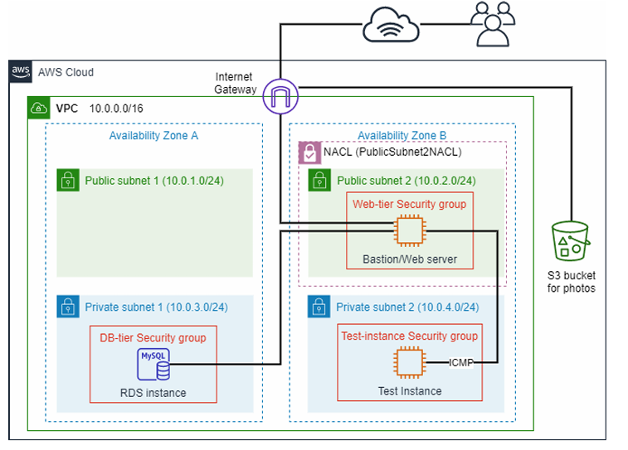

***Step 1.1: Generating the VPC***

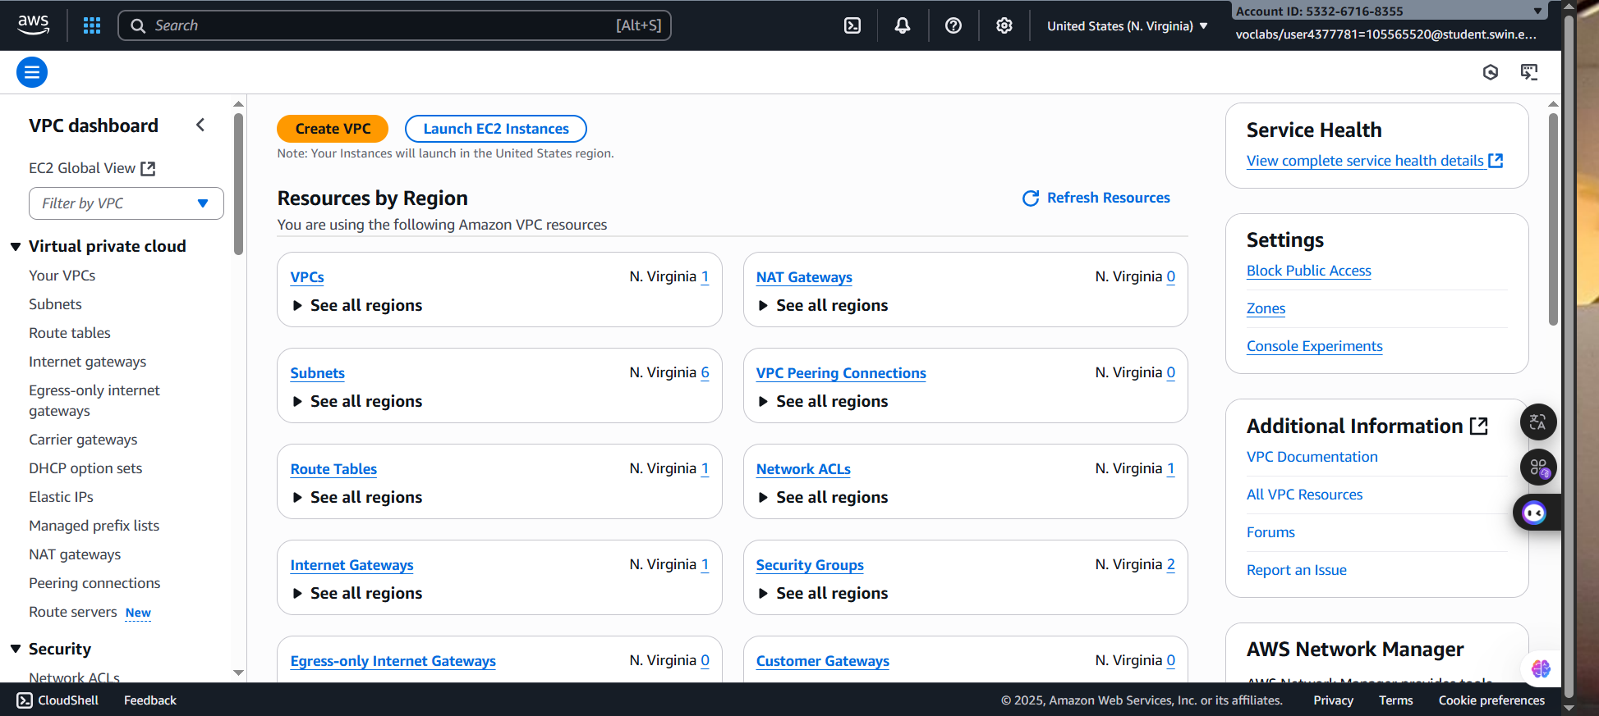 ***Step 1.1.1***: First and foremost, search and select the **VPC.**

***Figure 1: VPC Homepage***

***Step 1.1.2:*** Then, choose the **Create VPC** button. In the **VPC settings**, configure following settings:

- **Resources to create**: VPC and more

**- Auto-generate:** GHieuVPC

- **IPv4 CIDR block**: 10.0.0.0/16

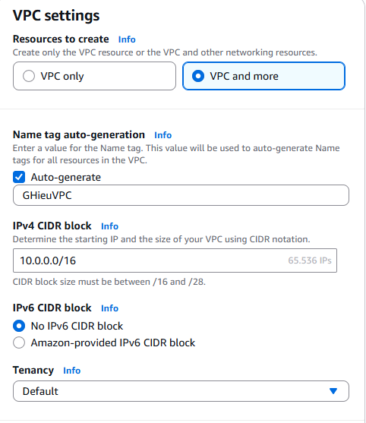

***Figure 2: VPC basic configuration***

**- Number of Availability Zones:** 2

+ First availability zone: use1-az4 (us-east-1a)

+ Second availability zone: use1-az6 (us-east-1b)

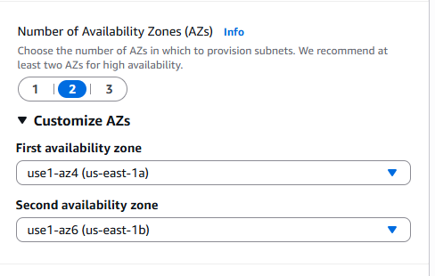***Figure 3: Availability zone configuration***

**- Number of public subnets:** 2

+ **Public subnet CIDR block in us-east-1a:** 10.0.1.0/24

+ **Public subnet CIDR block in us-east-1b:** 10.0.2.0/24

**- Number of private subnets:** 2

+ **Private subnet CIDR block in us-east-1a:** 10.0.3.0/24

+ **Private subnet CIDR block in us-east-1b:** 10.0.4.0/24

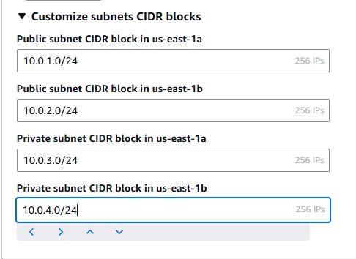

***Figure 4: IP address configuration***

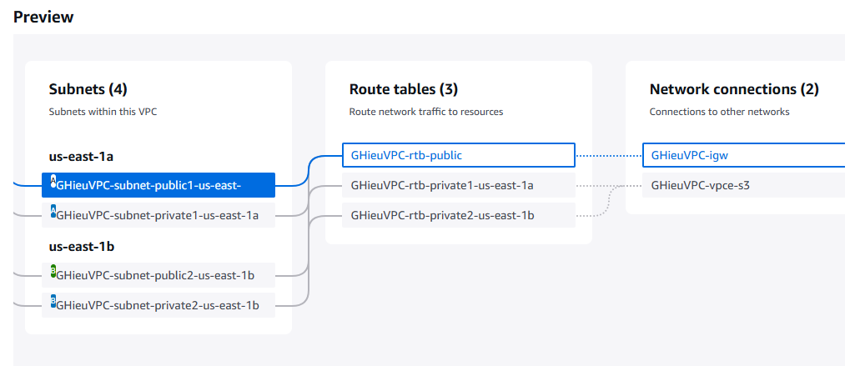***Figure 5: Preview check***

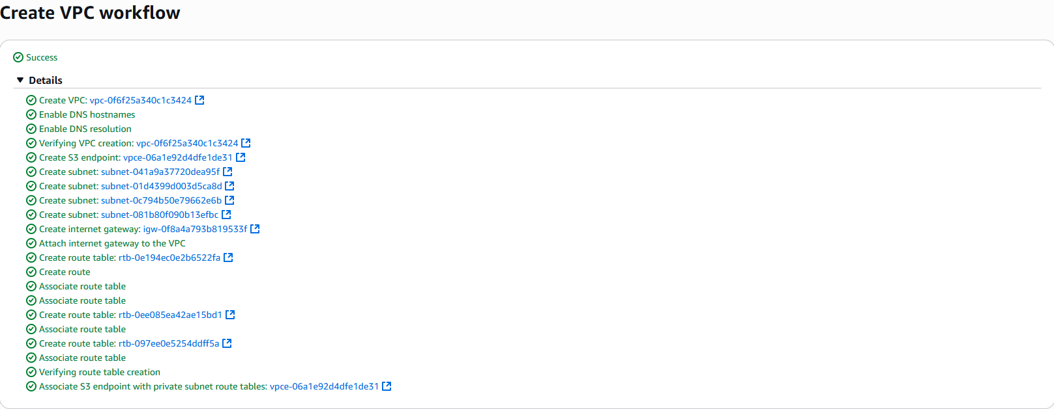 ***Step 1.1.3:*** After checking all configurations are correct, click button **Create VPC** to generate own VPC name “**GHieuVPC**”

***Figure 6: “GHieuVPC” created sucessfully***

***Step 1.2: Creating Security Groups***

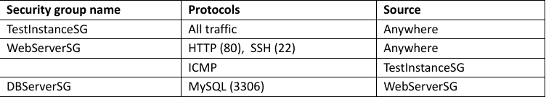 Create the following security groups, each is associated with each tier shown in the architecture diagram:

***Step 1.2.1:*** In the left navigation pane, choose **Security Groups**, and select the “**Create security group**” to create “**TestInstanceSG*”.***

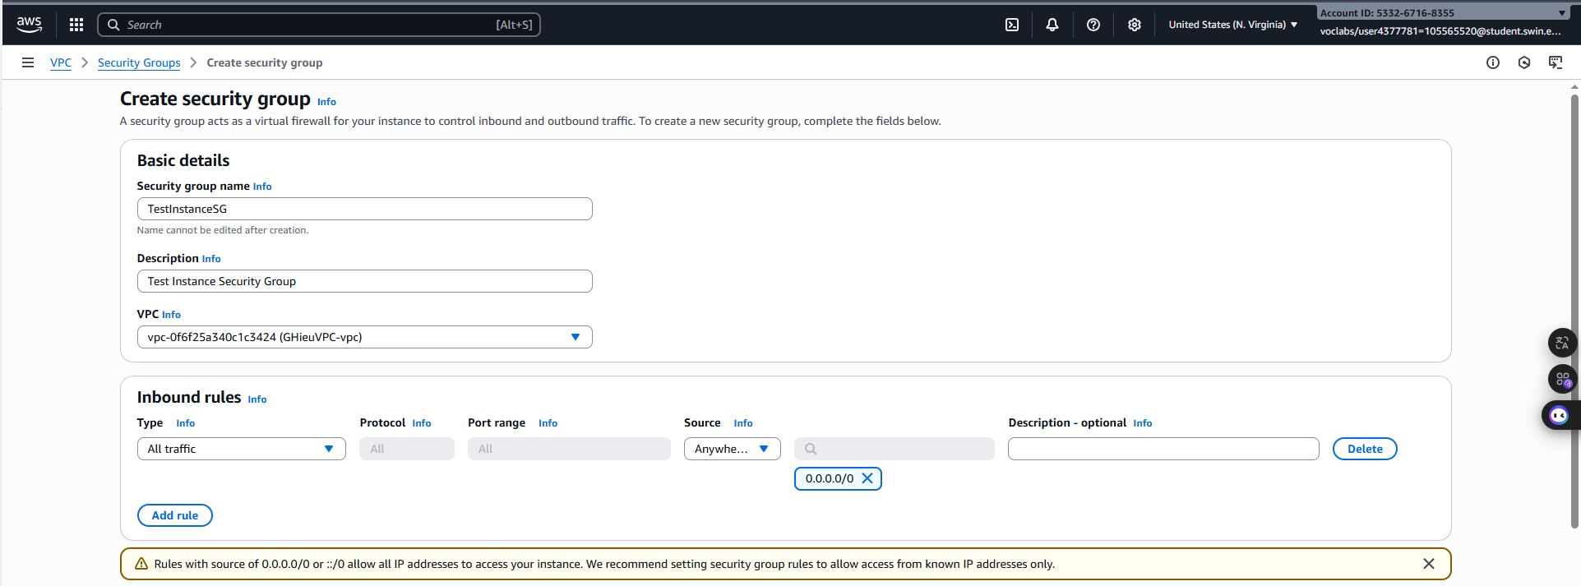***Figure 7: TestInstanceSG configuration***

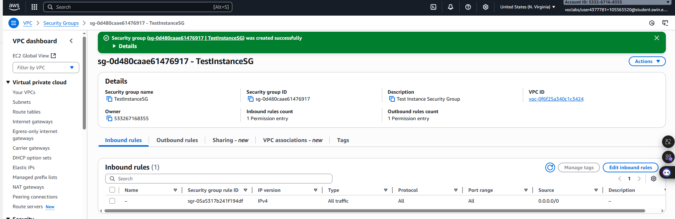 ***Step 1.2.2:*** By making sure all settings for the **TestInstanceSG** are correct, click the button **Create security group** to generate.

***Figure 8: TestInstanceSG created successfully***

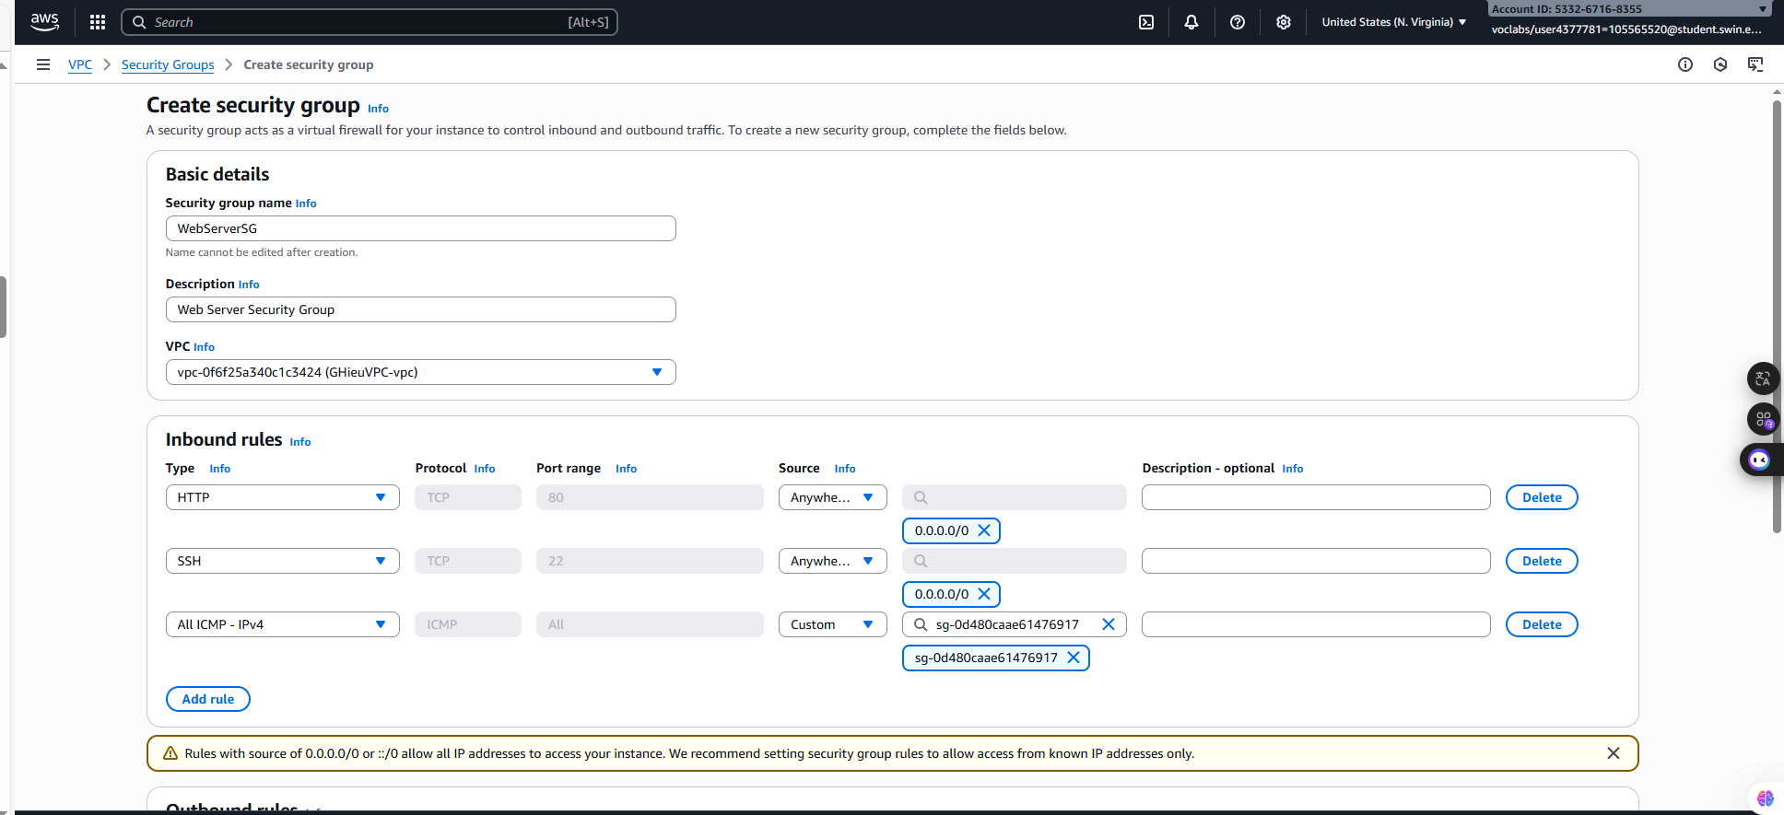 ***Step 1.2.3:*** Similarly to **WebServerSG**

***Figure 9: WebServerSG configuration***

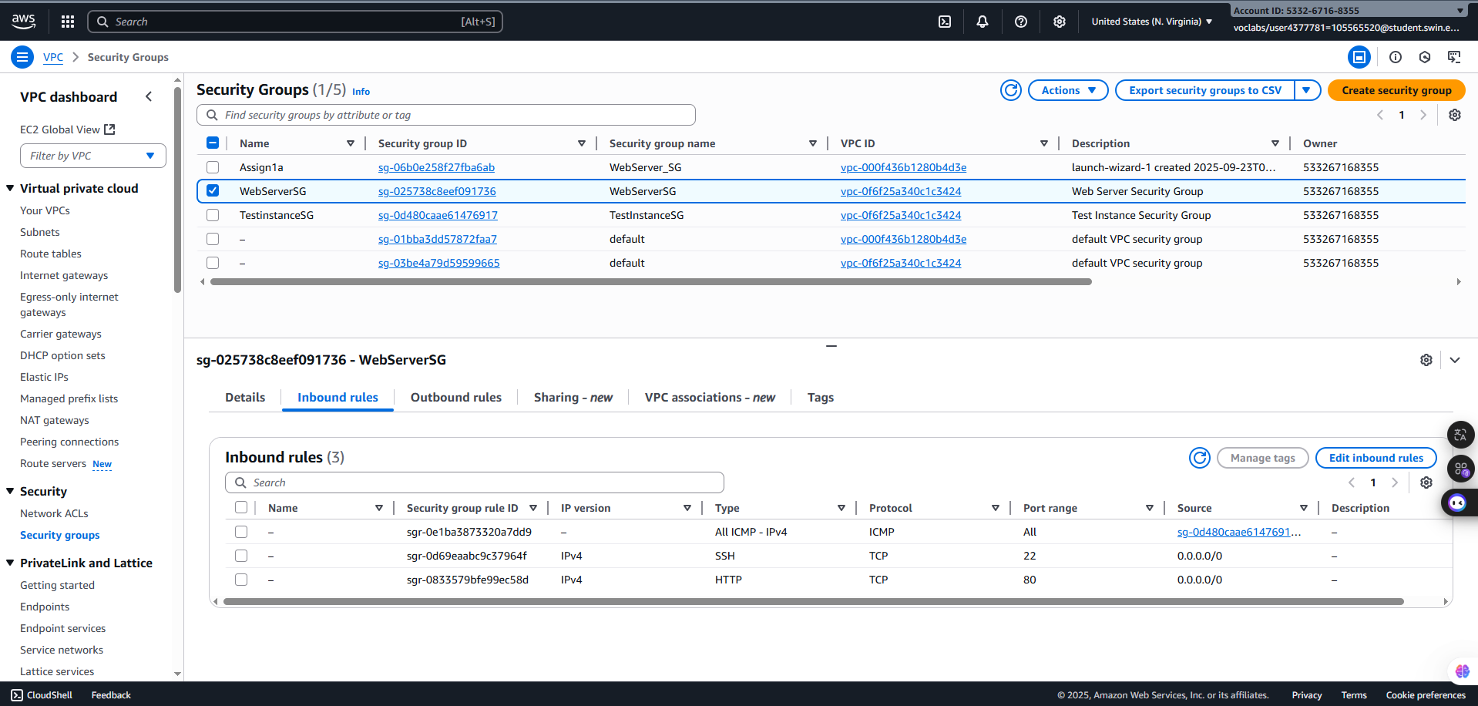 ***Step 1.2.4:*** Then, click the button **Create security group** to generate

***Figure 10: WebServerSG created successfully***

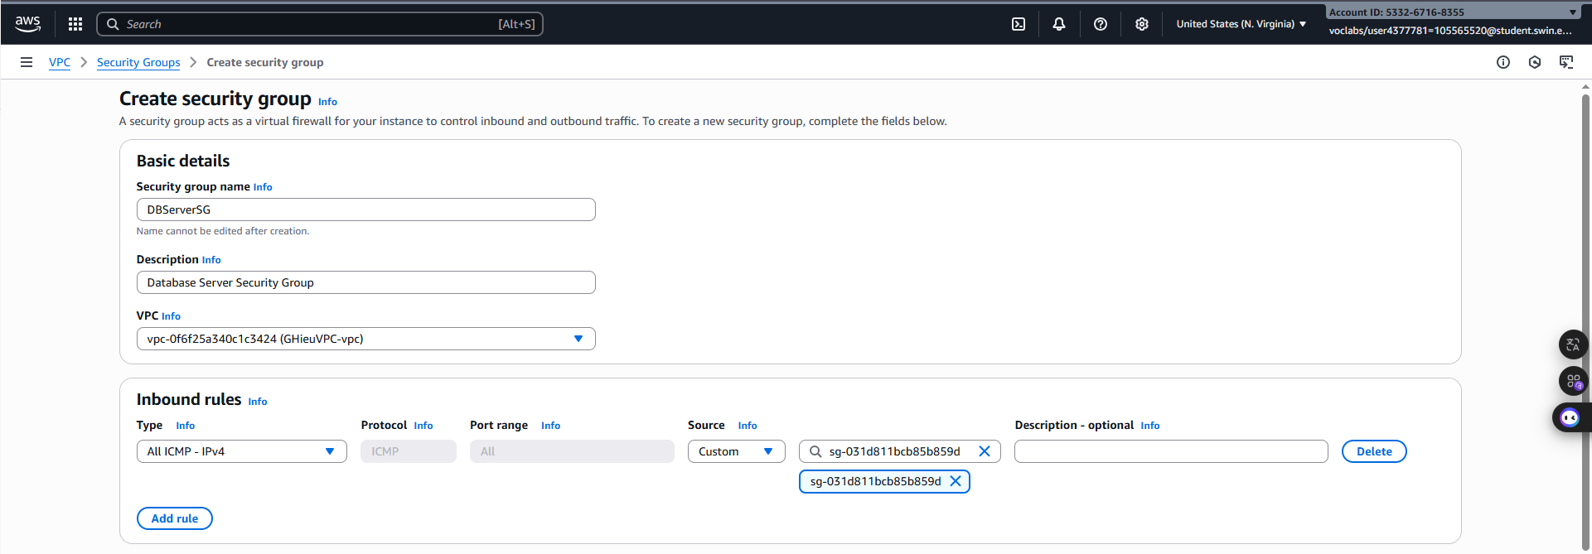 ***Step 1.2.5:*** Finally, created the **DBServerSG**

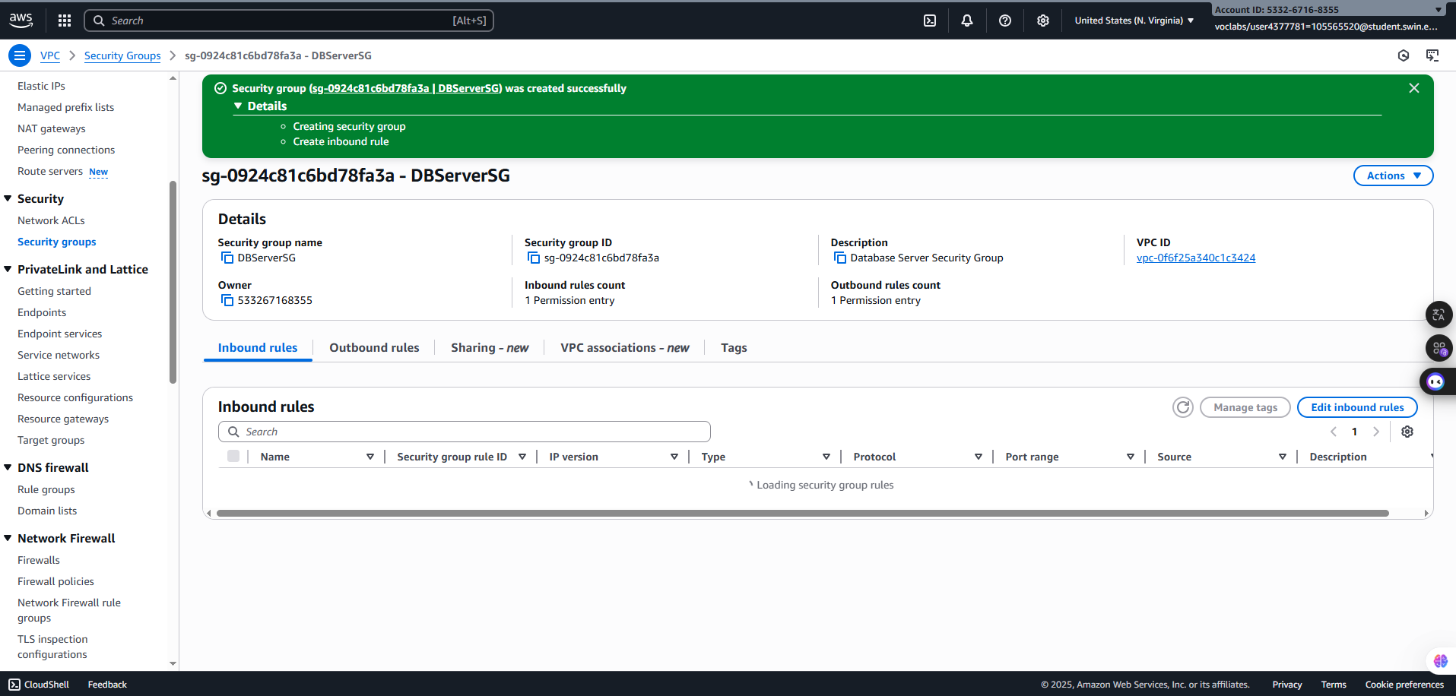***Figure 11: DBServerSG configuration***

***Figure 12: DBServerSG created successfully***

***Step 1.3: Create Instances***

***Step 1.3.1:*** Create **Bastion/Web server instance**and configure following:

+ **Name**: Bastion/Web server instance

+ **AMI**: Amazon Linux 2023

+ **Instance type**: t2.micro

+ **Key Pair**: Assignment1a

+ Network Settings:

* **VPC**: GHieuVPC

* **Subnet**: Public Subnet 2

* **Select existing security group:** WebServerSG

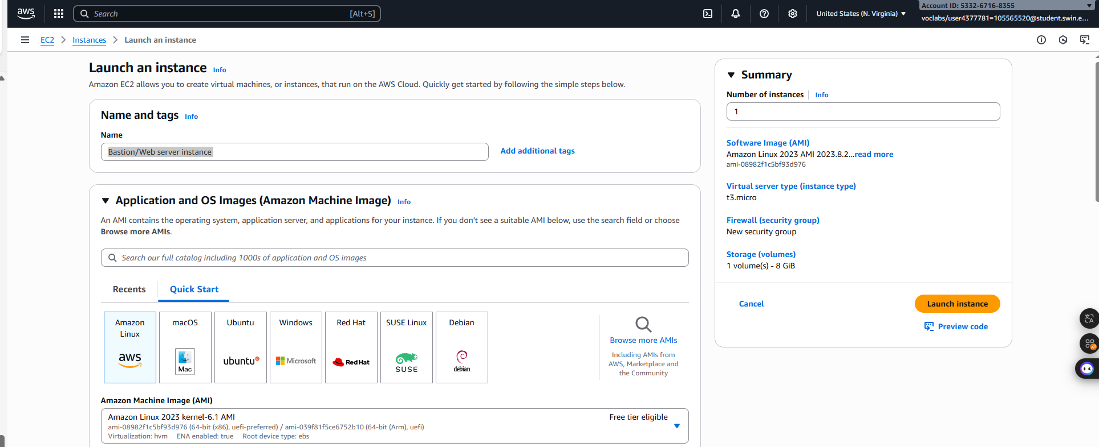 **+ User Data**: Paste from Install_PHP_AWS_0.2

***Figure 13: Name and AMI configuration***

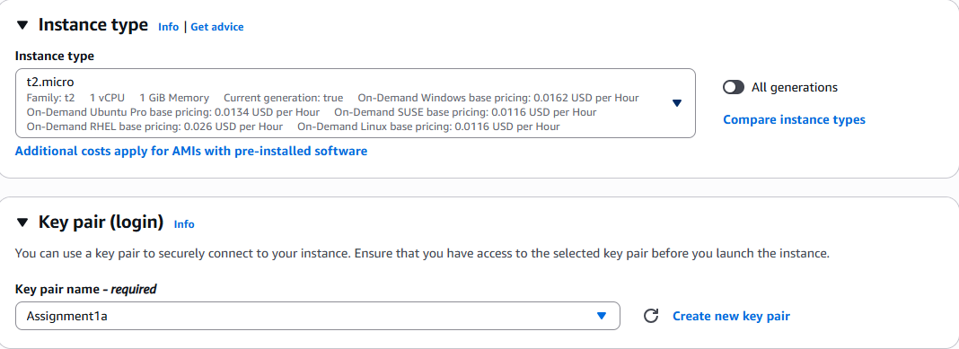

***Figure 14: Instance and key pair configuration***

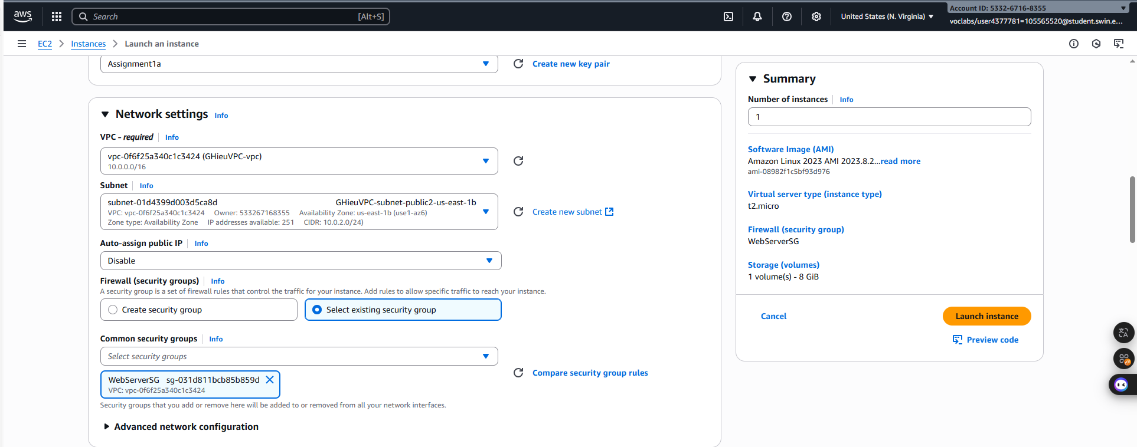

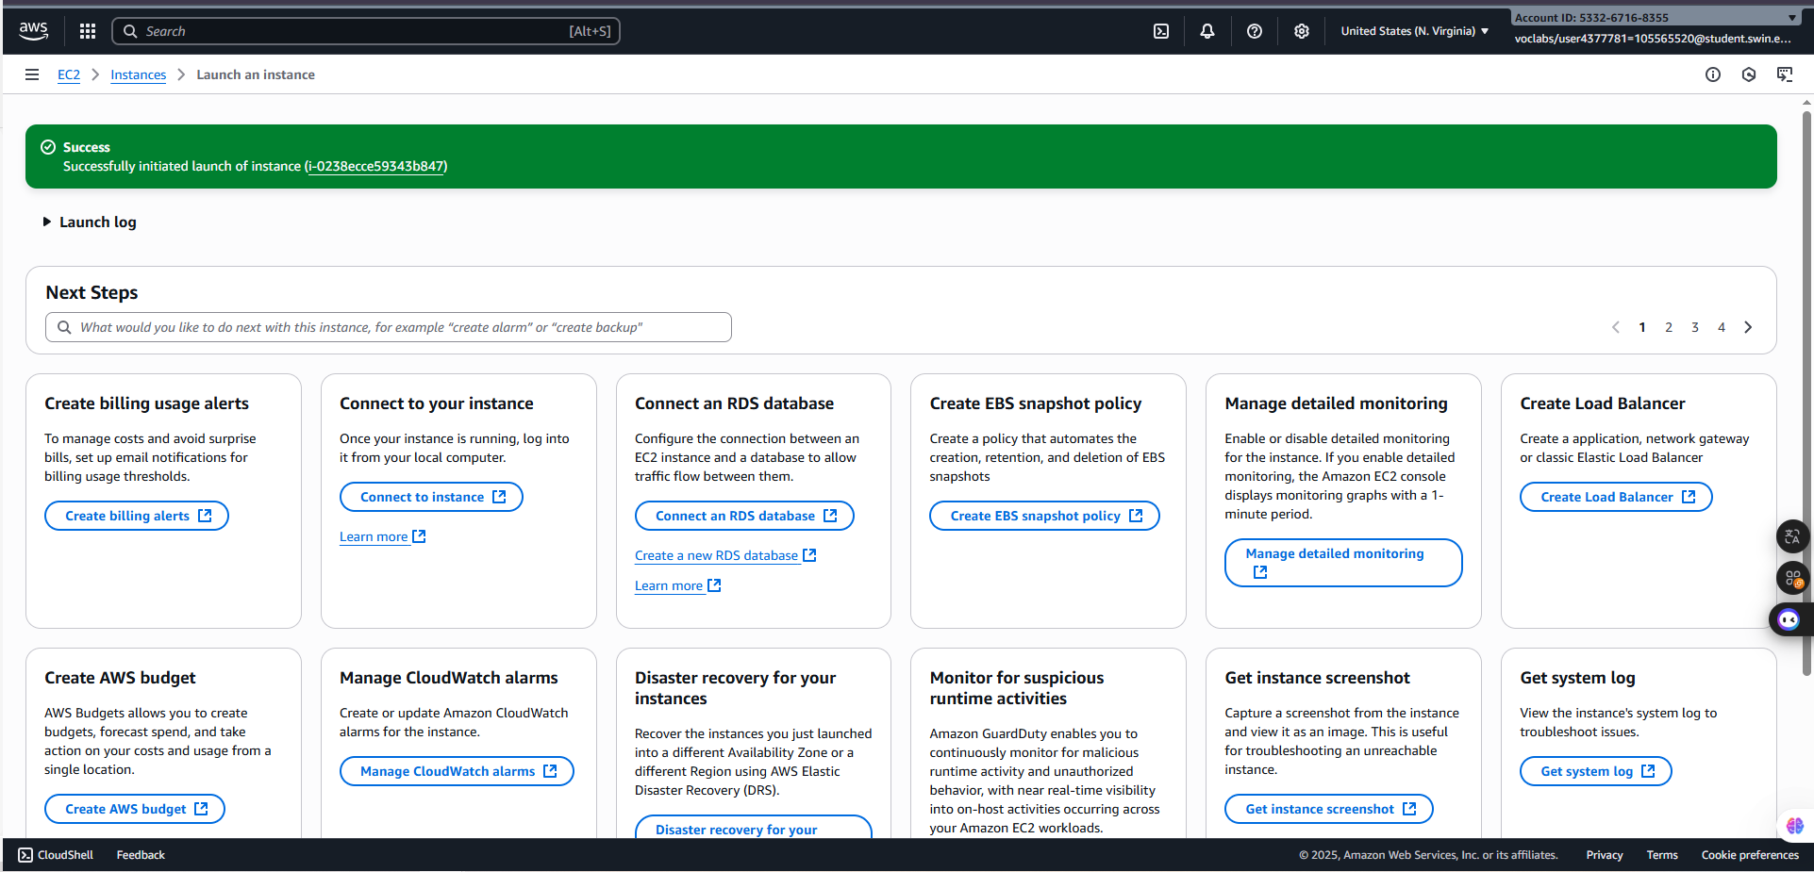 ***Figure 15: Network settings configuration***

***Figure 16: Instance created successfully***

***Step 1.3.2***: Next, choose the **Elastic IPs**, and choose **Allocate Elastic IP address**

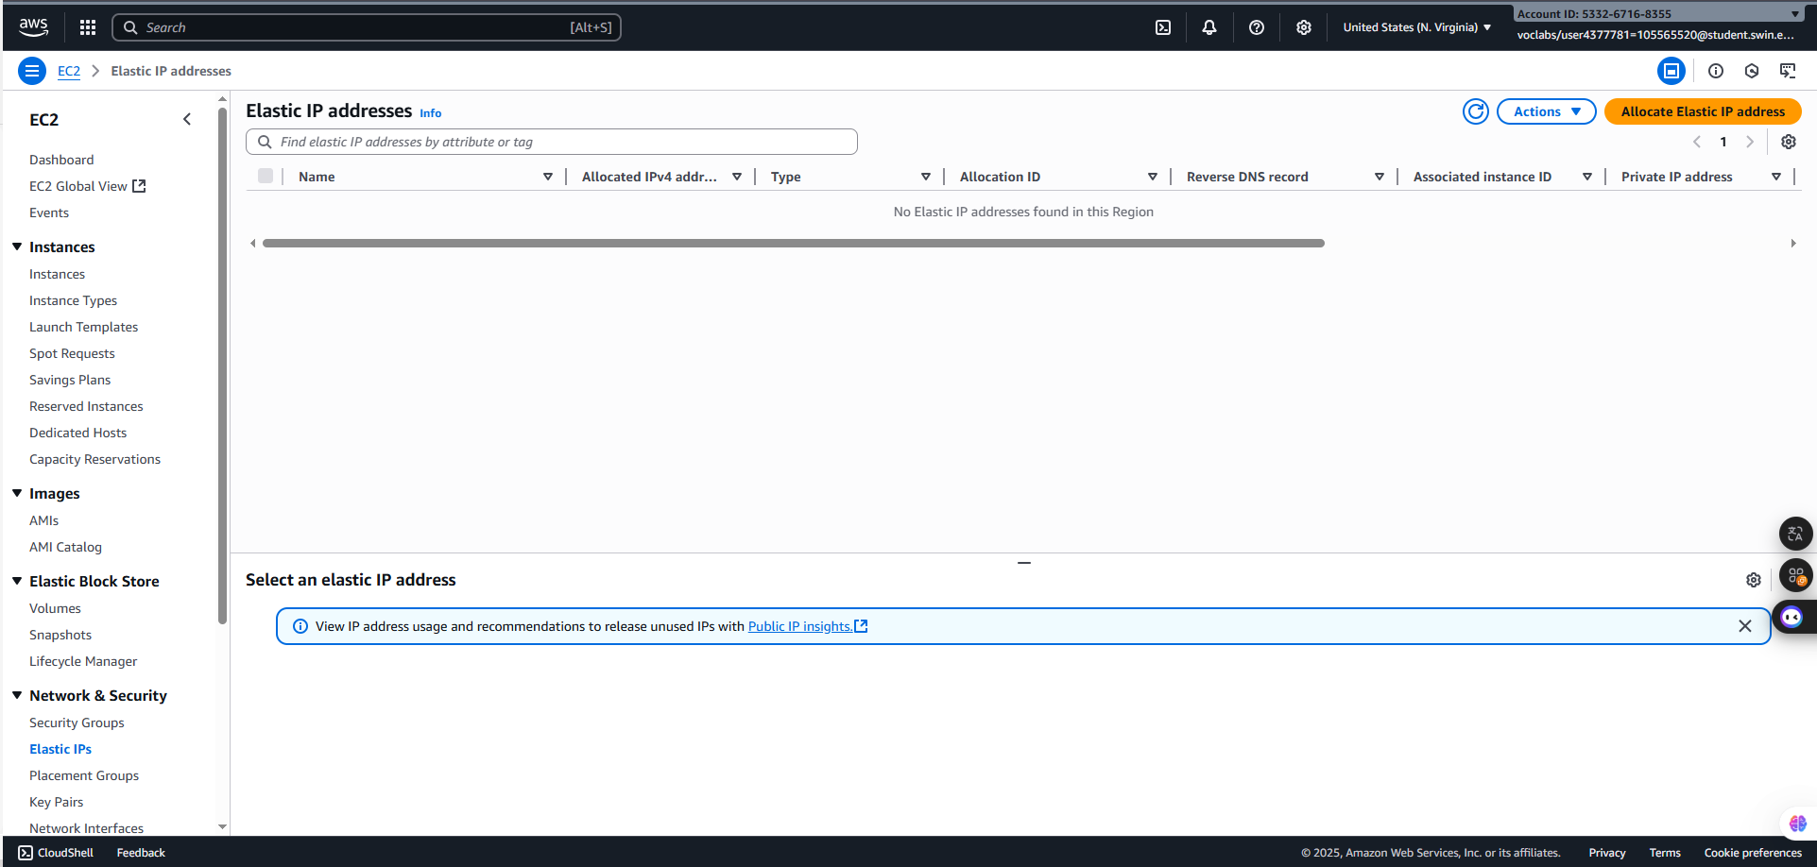

***Figure 17: Elastic IPs window***

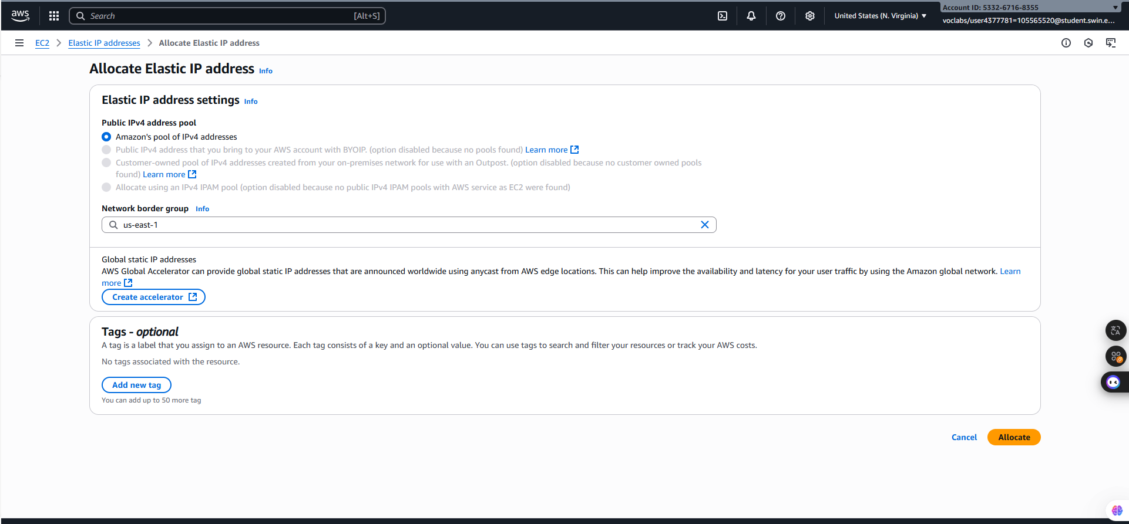 ***Step 1.3.3:*** After clicking the button, choose **Allocate**

***Figure 18: Allocate configuration***

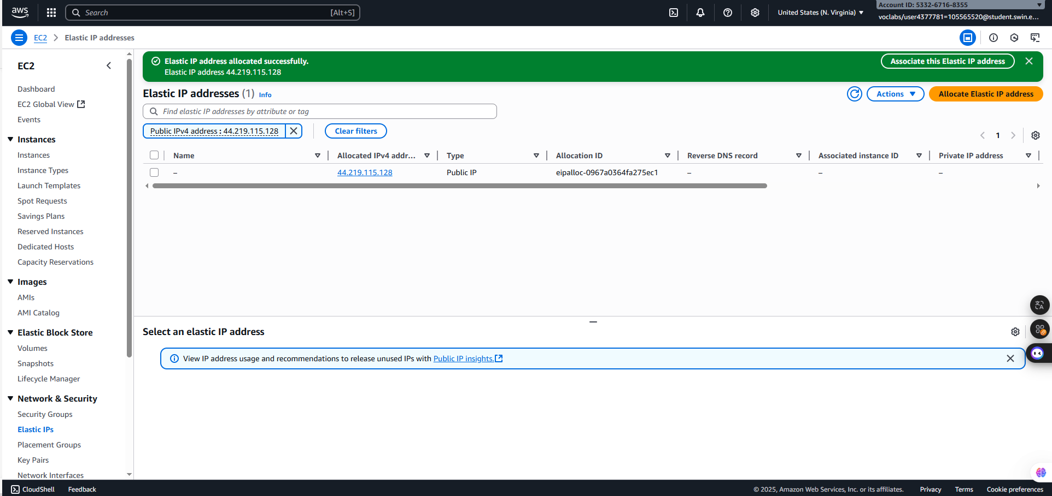

***Figure 19: Allocate created successfully***

***Step 1.3.4:*** Then, tick the box, choose **Actions => Associate Elastic IP address** and select the **Bastion/Web server instance** in the **Instance**

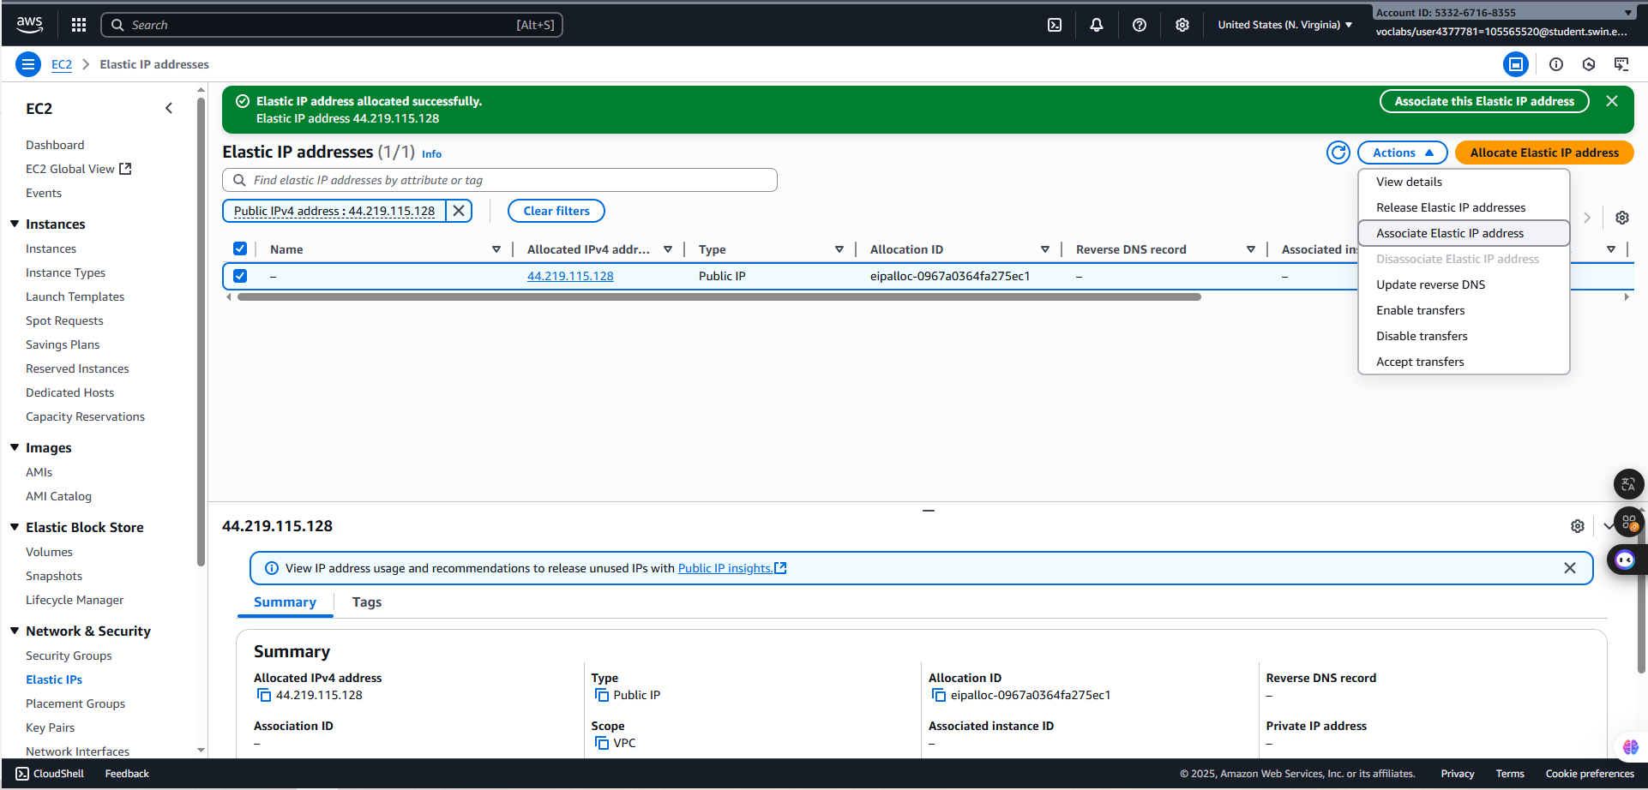

***Figure 20: Action selection***

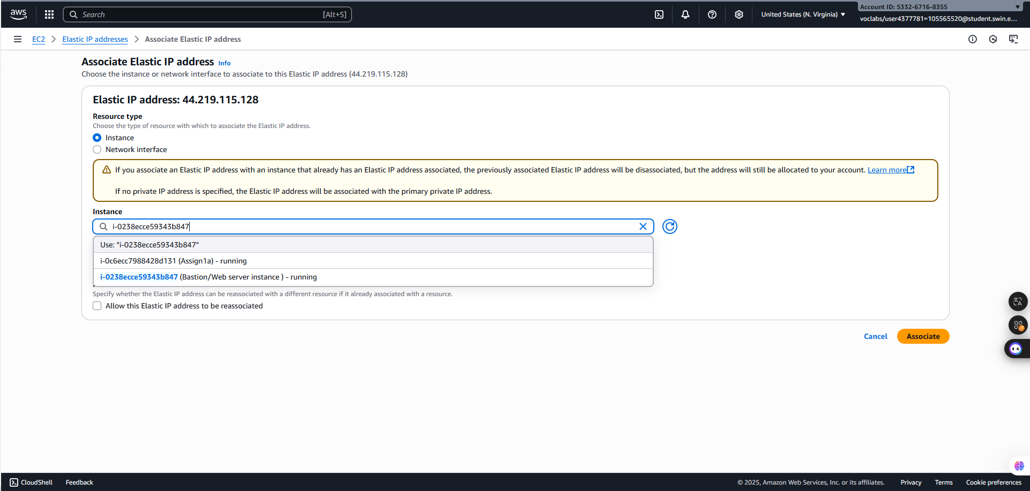***Figure 21: Allocation configuration***

***Figure 22: Allocation c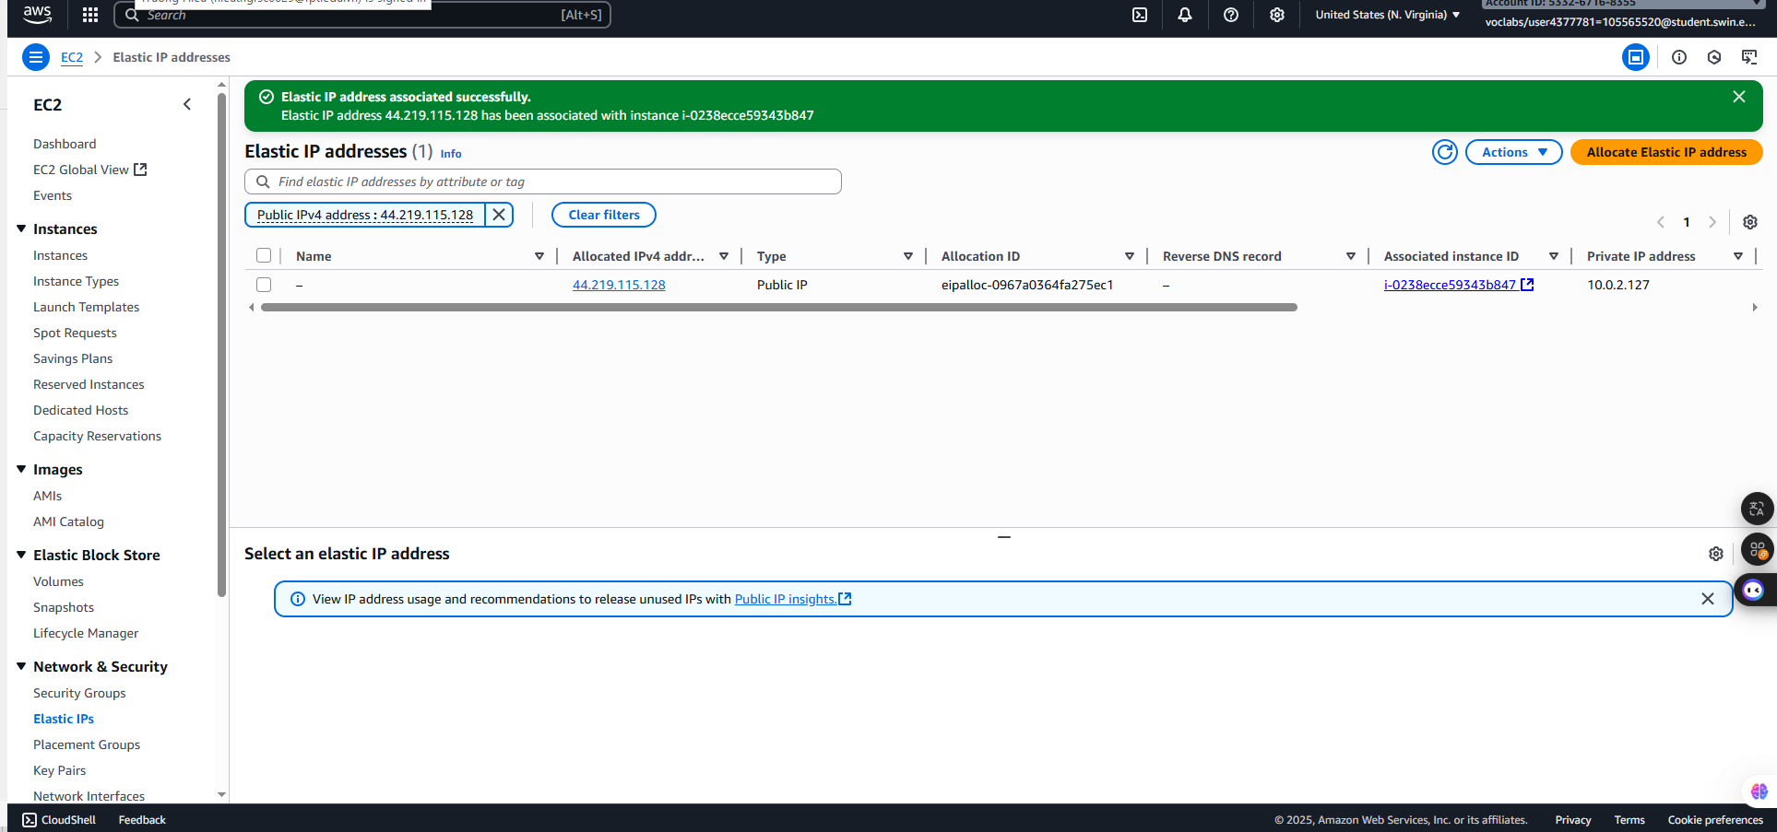reated successfully***

***Step 1.3.5:*** Create **Test Instance**

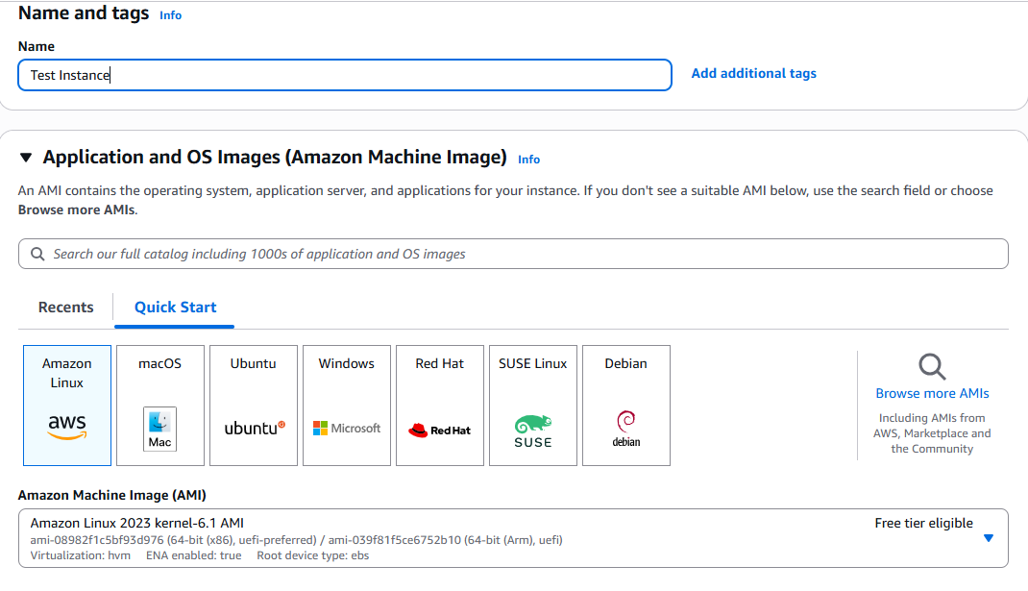

***Figure 23: Test Instance’s Name and AMI Configuration***

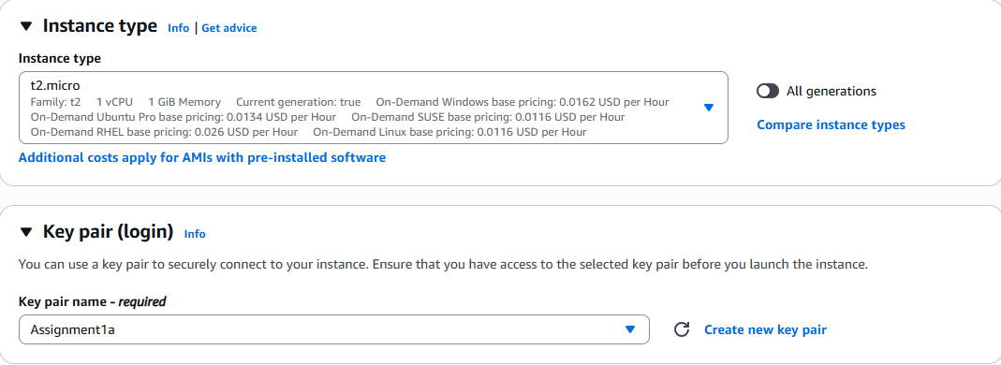

***Figure 24: Test Instance’s type and Key pair configuration***

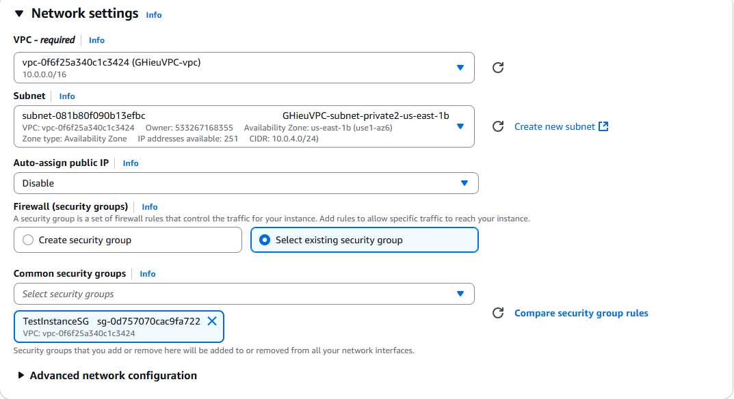

***Figure 25: Test Instance’s network settings configuration***

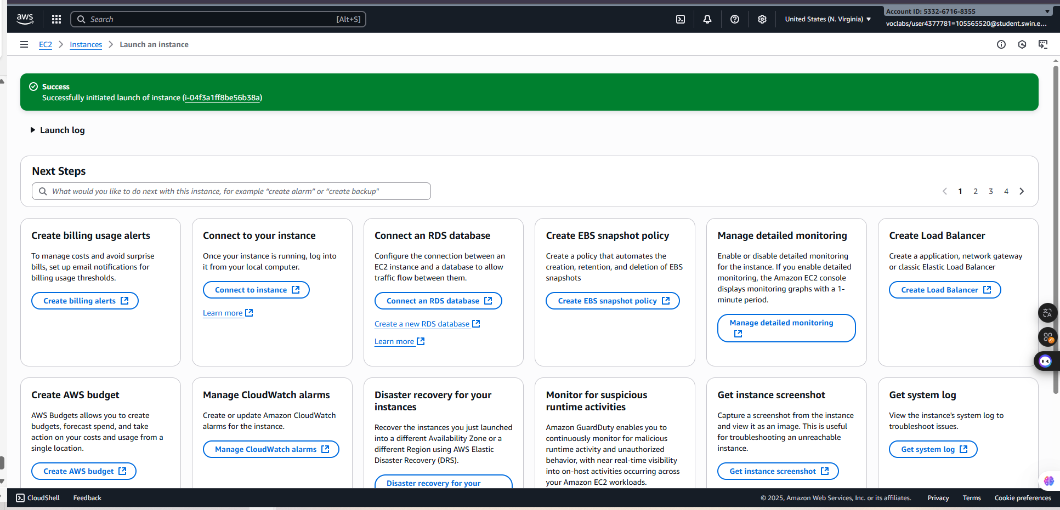

***Figure 26: Test Instance’s created successfully***

***Step 1.3.6:*** Choose Instances to view all **Instances**

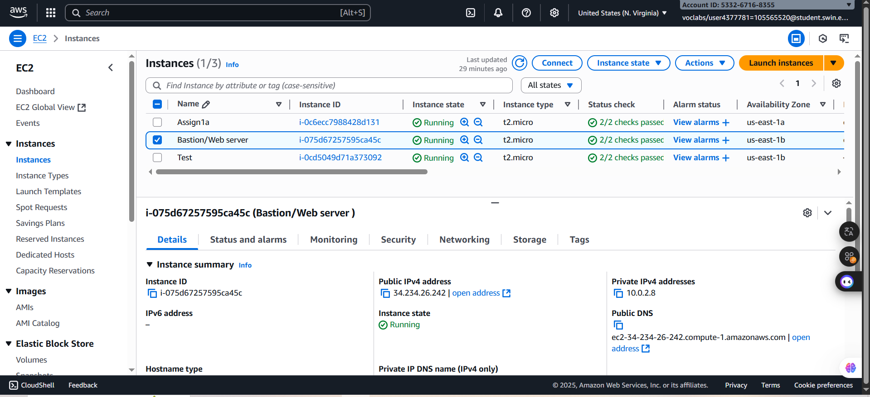

***Figure 27: Instance board***

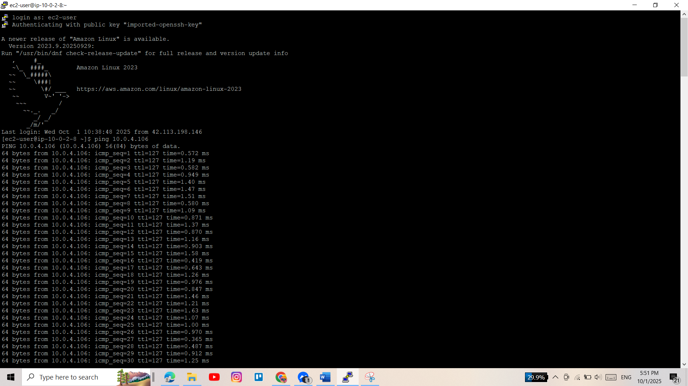 ***Step 1.3.7:*** In the next step, open the **Putty**, copy the **public DNS link** of the **Bastion/Web server instance** and upload the key pair “**Assignment1a.ppk**” to test ping from **Bastion//Web server to Test instance**

***Figure 28: Test ping from Bastion to Test instance successfully***

***Step 1.3.8:*** Then, test ping ftom Test to Bastion instance constrast

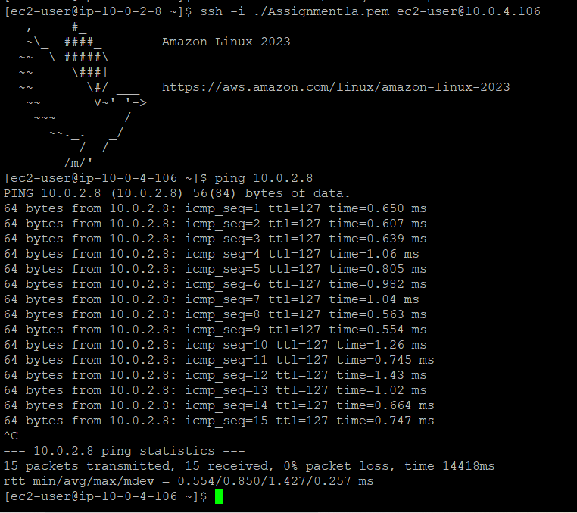

***Figure 29: Test ping from Test to Bastiont instance successfully***

***Step 1.4: RDS database instance***

***Step 1.4.1:*** Search and select the **Aurora and RDS** service

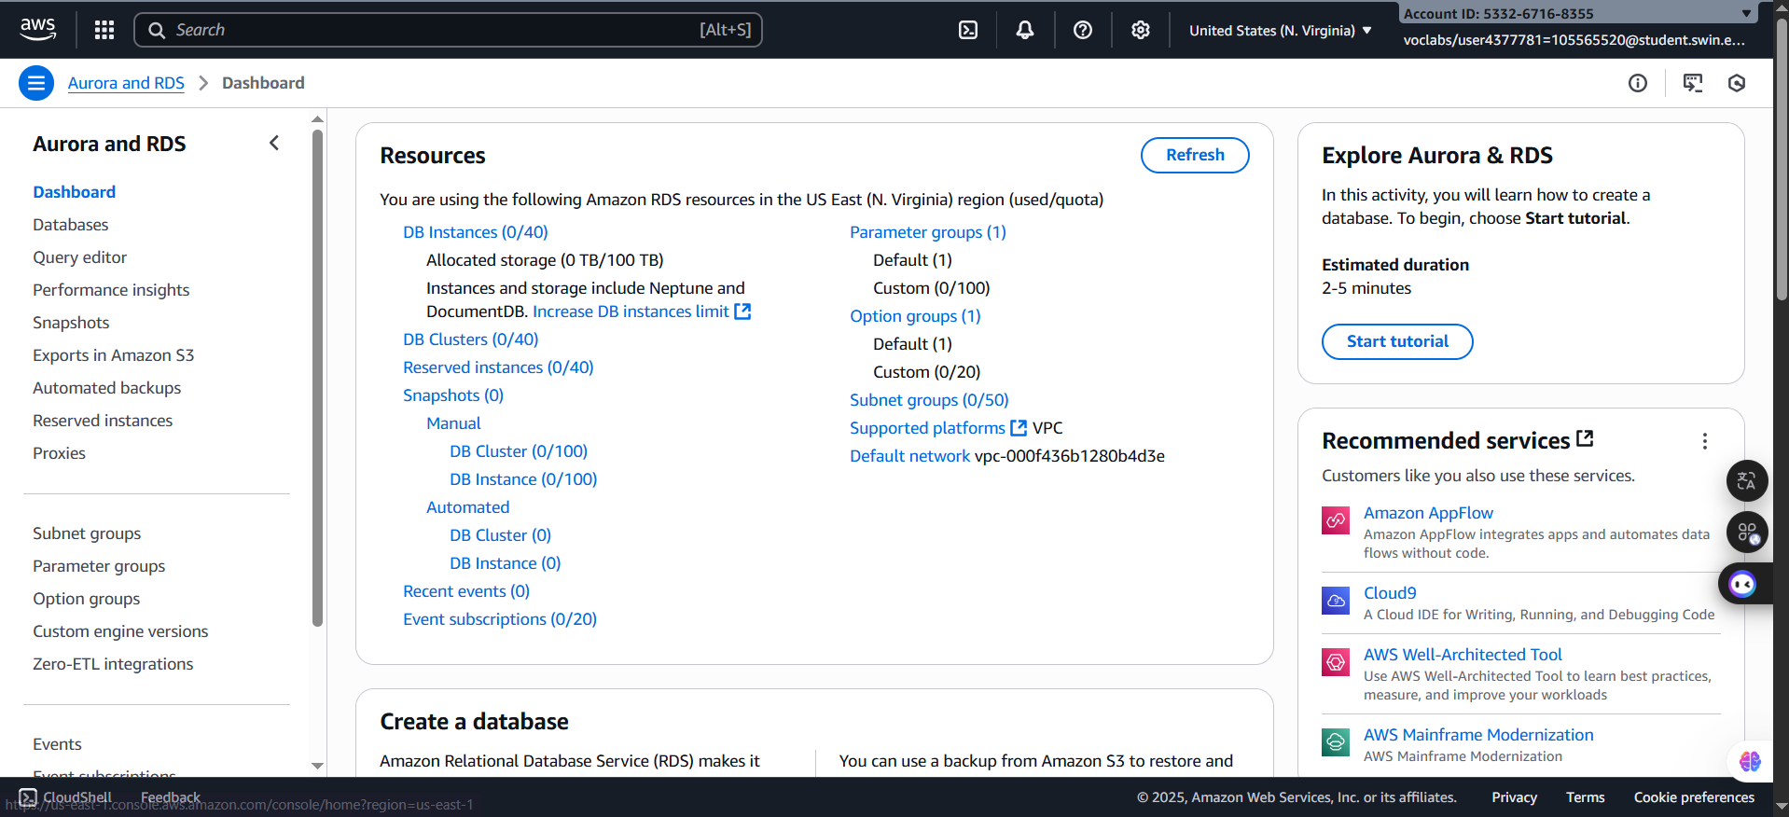

***Figure 30: Aurora and RDS mainpage***

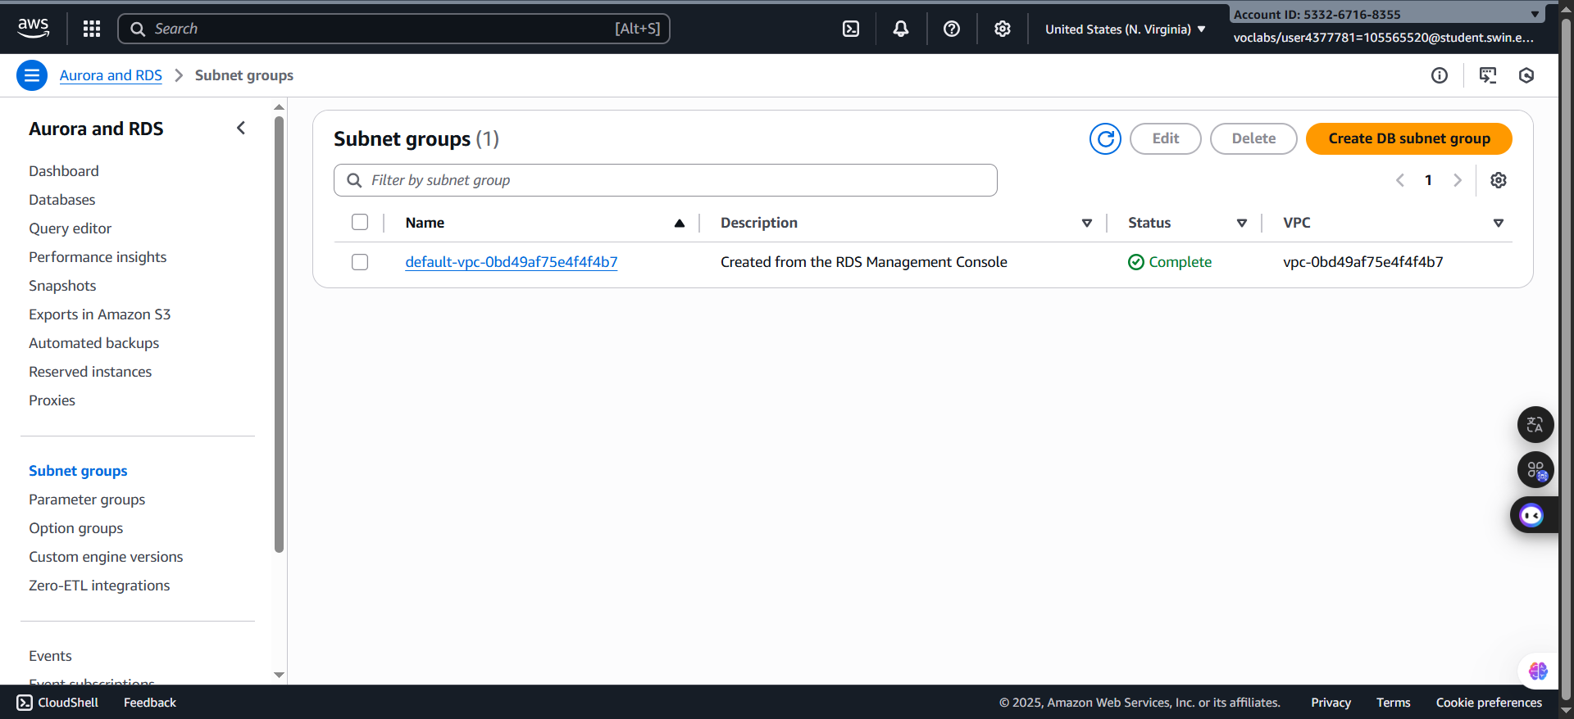 ***Step 1.4.2:*** In the left navigation, choose the **Subnet groups** and press button **Creare DB subnet group**

***Figure 31: Create DB Subnet group subpage***

***Step 1.4.3***: Then, configure:

**+ Name:** DBSubnetGroup

+ **Description:** Private subnet group

+ **VPC:** THieuVPC

+ **Add subnets:**

**\* Availability Zones:** us-east-1a and us-east-1b

* **Subnets:** 10.0.3.0/24 and 10.0.4.0/24

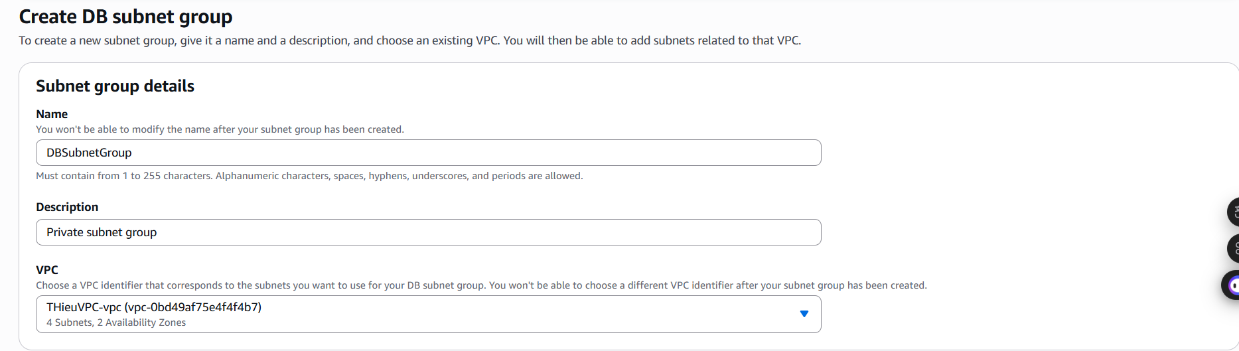***Figure 32: Subnet Group details configuration***

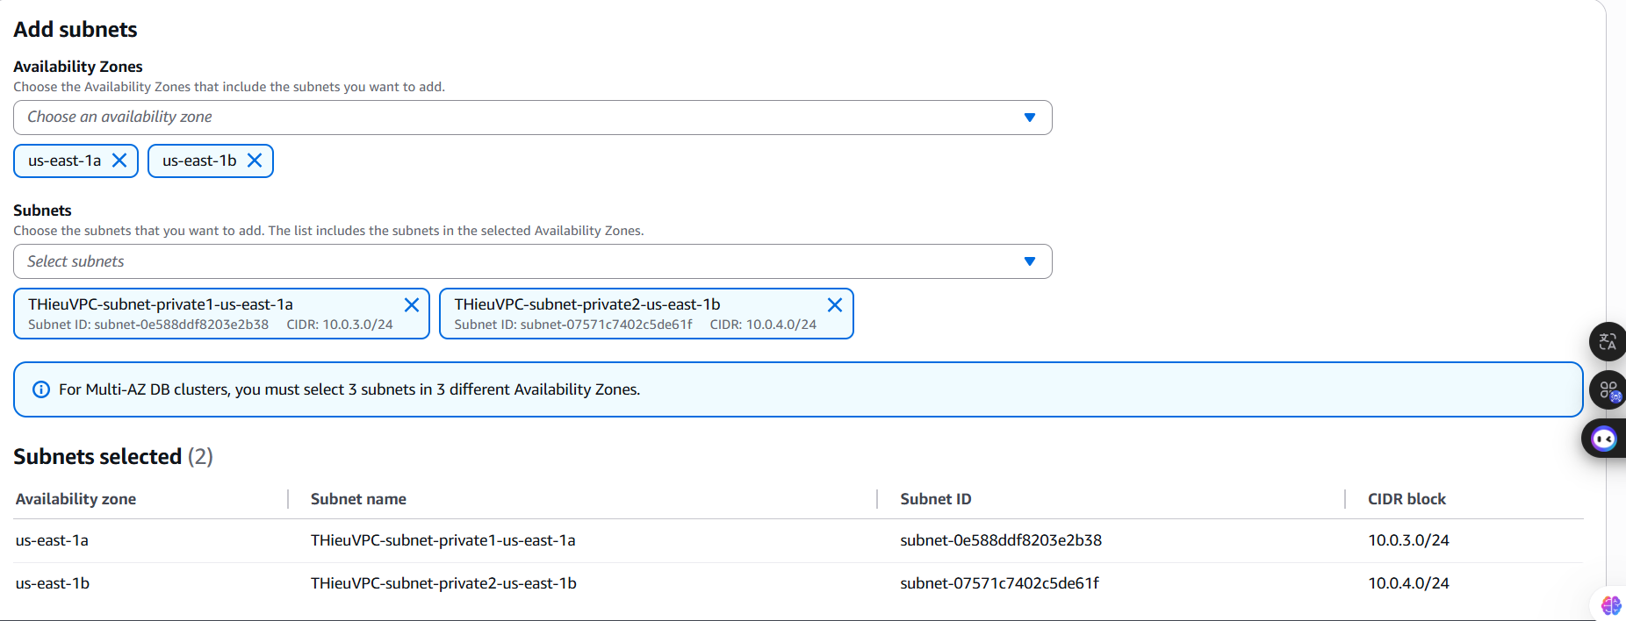

***Figure 33: Add subnets configuration***

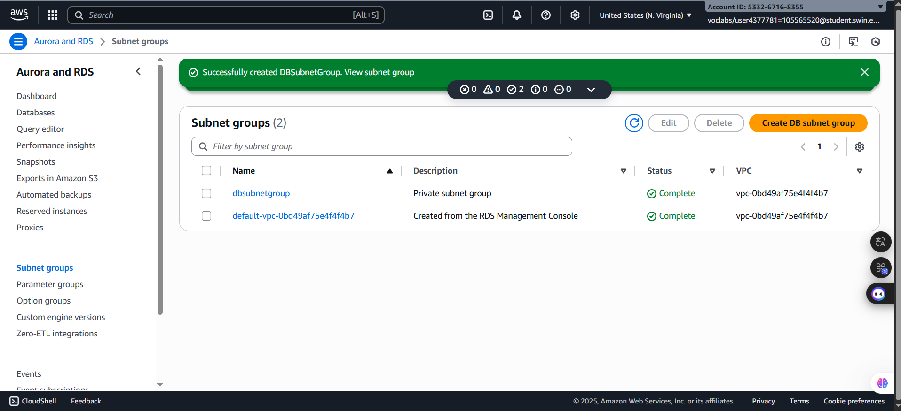

***Figure 34: DBSubnetGroup created successfully***

***Step 1.4.4:*** Choose the **Databases** in the left navigation pane and select the **Create database button** with following configure:

+ **Public access**: No

+ **Choose a database creation method:** Standard create

+ **Engine type:** MySQL

+ **Engine version:** MySQL 8.0.39

+ **Templates:** Free Tier (Sandbox)

+ **DB instance identifier:** Assignment1b-database

+ **Password:** password

**+ Confirm master password:** password

+ **Compute resource:** *Don’t connect to an EC2 compute resource*

**+ Network Type:** IPv4

+ **Virtual private cloud (VPC):** THieuVPC

+ **DB subnet group:** DBSubnetGroup

+ **Availability Zone:** us-east-1a

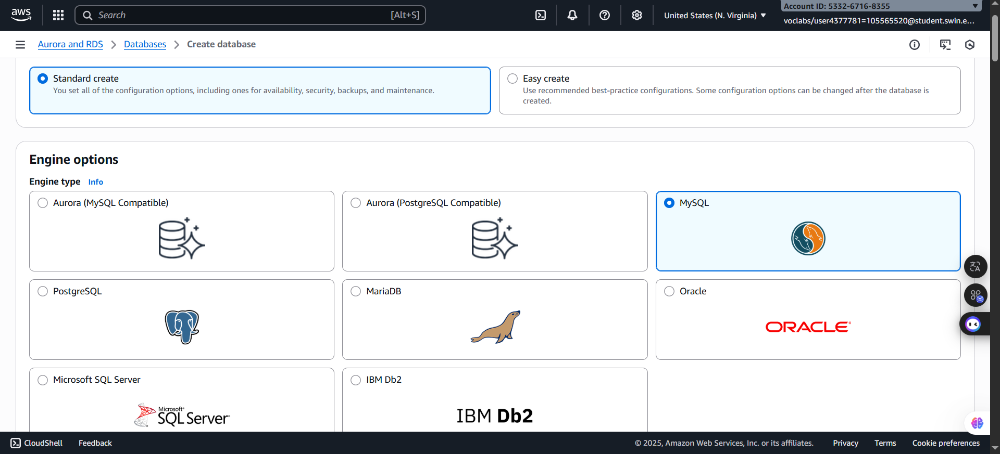

***Figure 35: Database method and engine configuration***

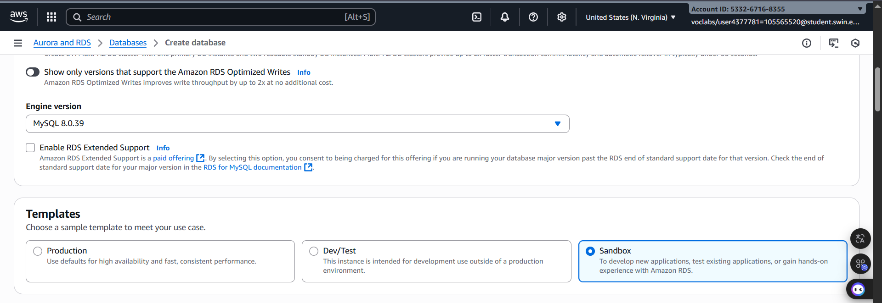

***Figure 36: Engine version and Templates configuration***

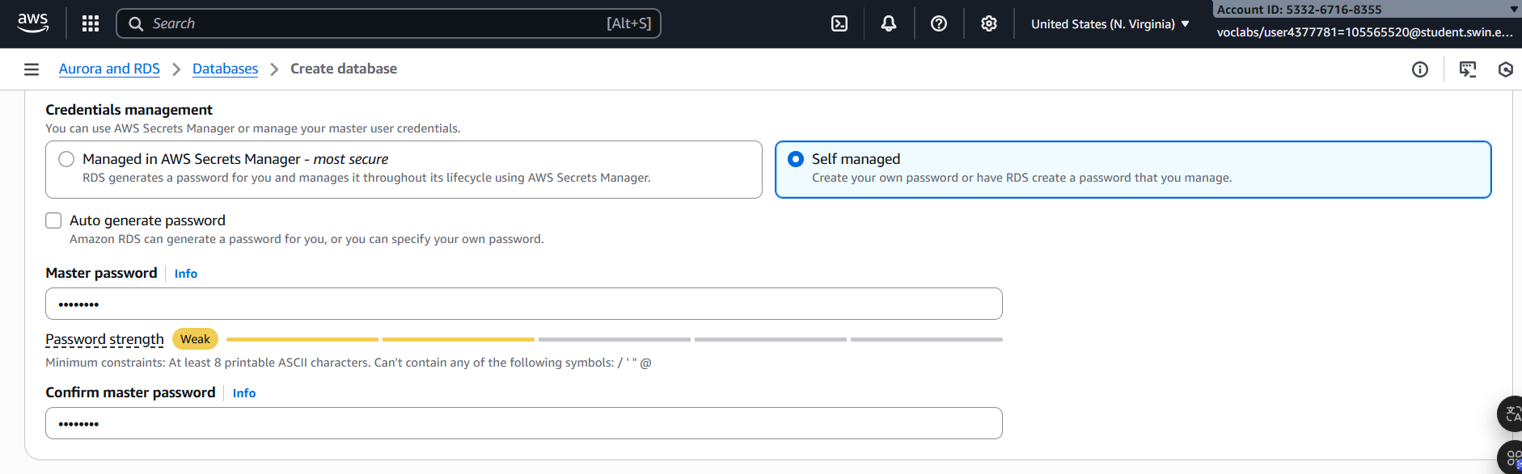

***Figure 37: Hostname and password configuration***

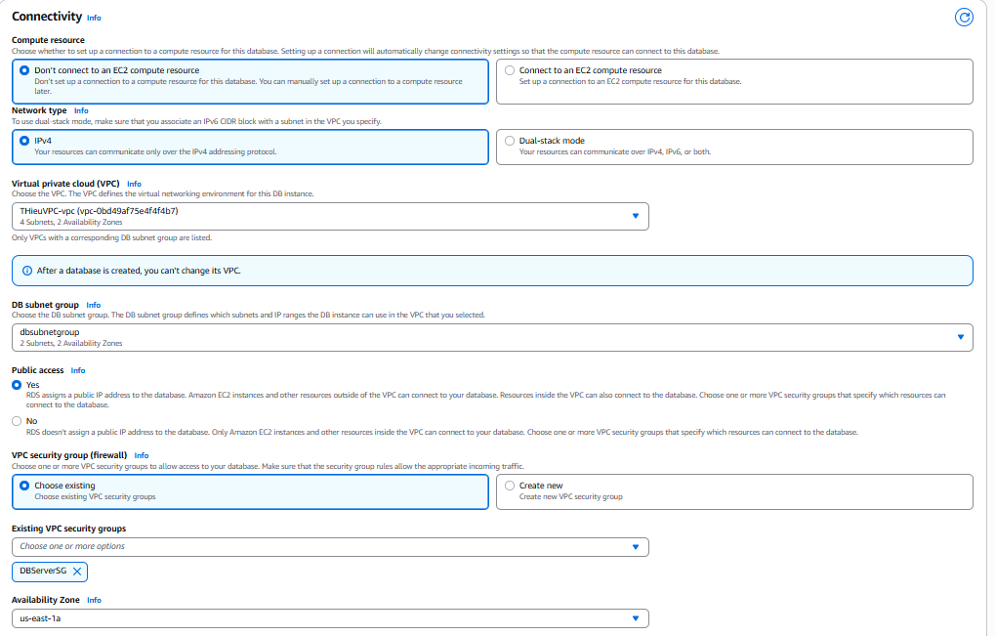

***Figure 38: Connectivity configuration***

***Step 1.4.5:*** Open the Putty.exe, paste the **punlic DNS link of the Bastion/Web server instanc**e and upload the private key pair

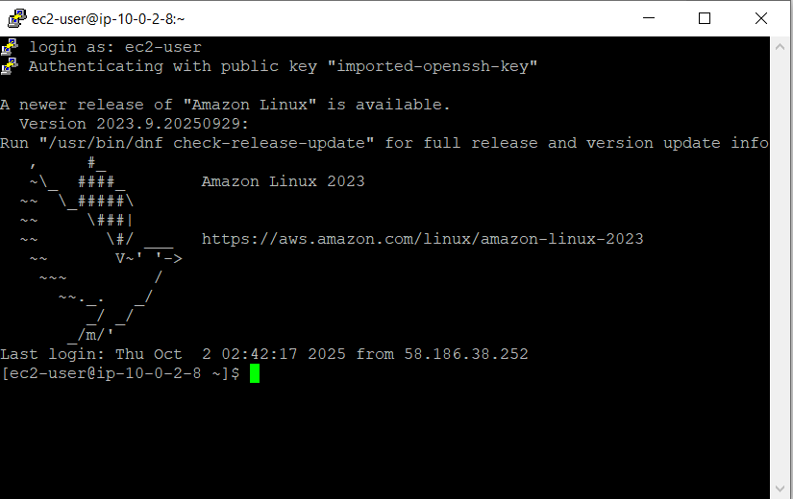

***Figure 39: Login successfully***

***Step 1.4.6:*** Navigate to the Apache document root directory:

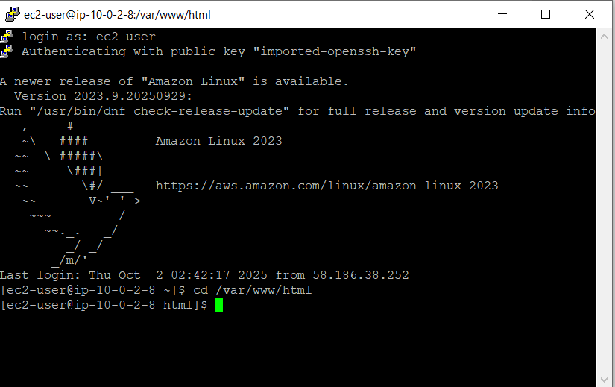cd /var/www/html

***Figure 40: Changed directoty successfully***

***Step 1.4.7:*** Download phpMyAdmin source file:

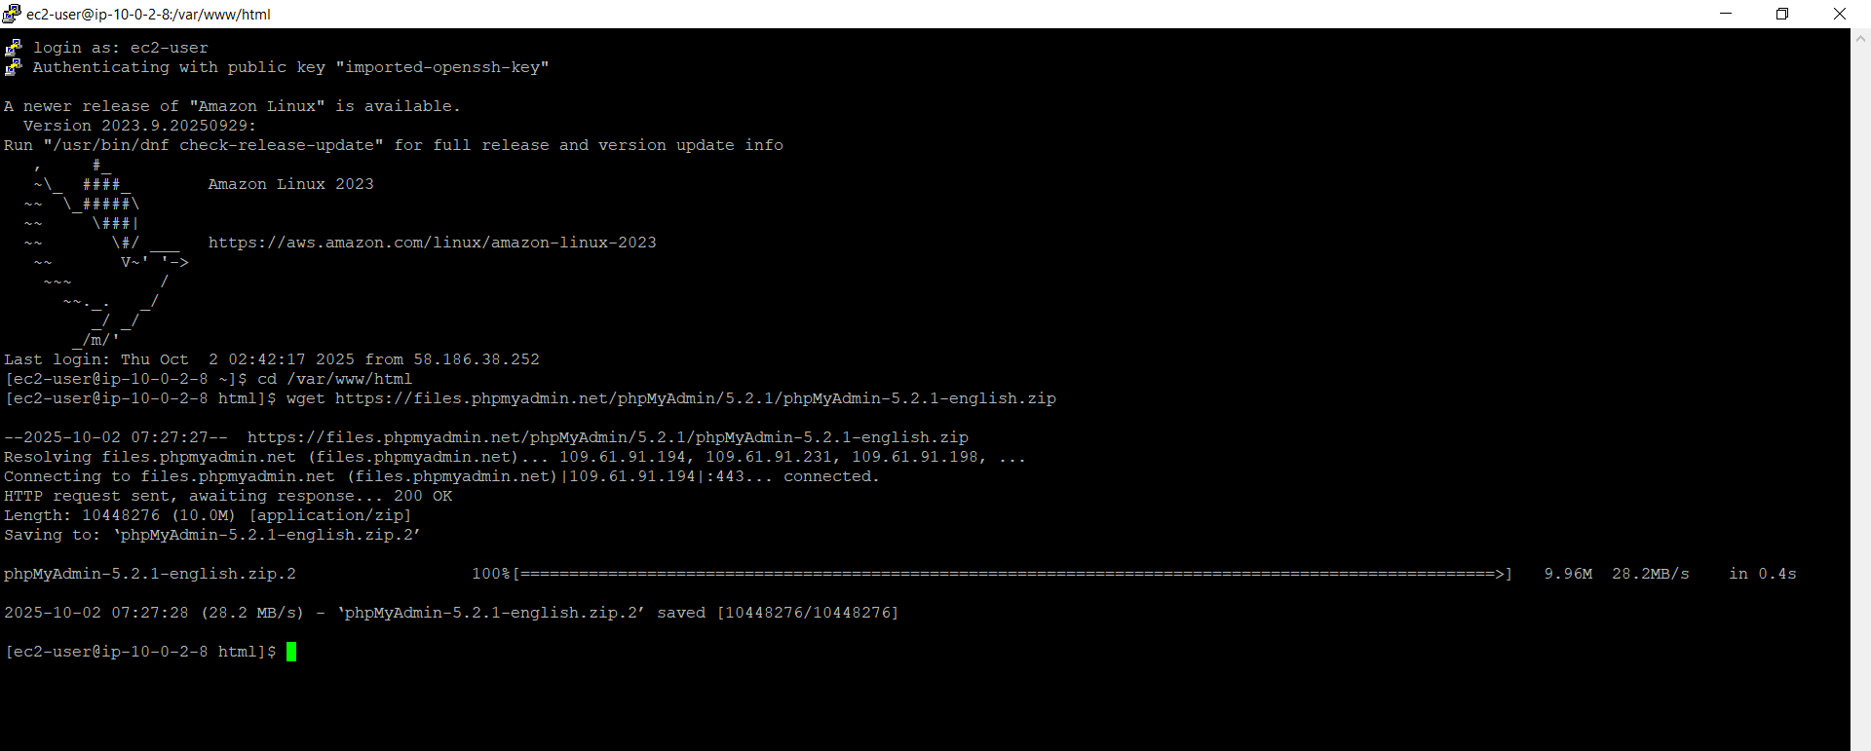wget https://files.phpmyadmin.net/phpMyAdmin/5.2.1/phpMyAdmin-5.2.1-english.zip

***Figure 41: Download phpMyAdmin sources successfully***

***Step 1.4.8:*** Unzip the downloaded zip file:

unzip phpMyAdmin-5.2.1-english.zip

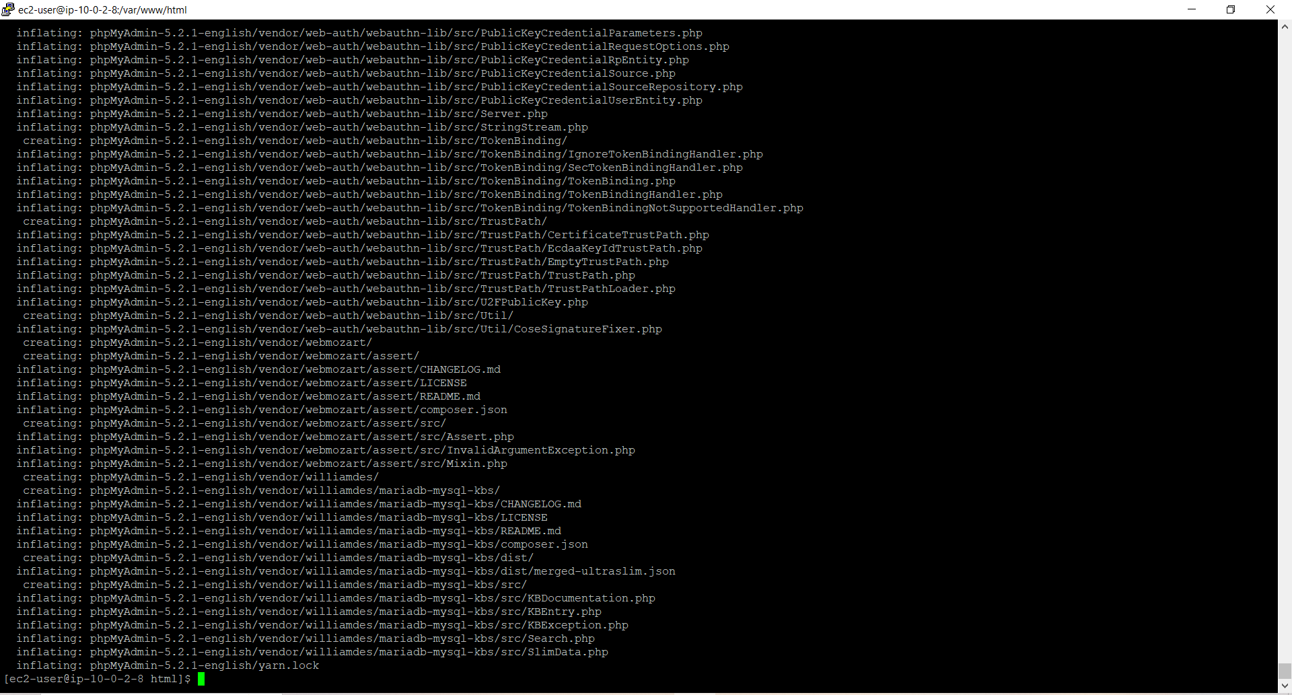***Figure 42: Unzip successfully***

***Step 1.4.9*:** Change the directory name to phpmyadmin:

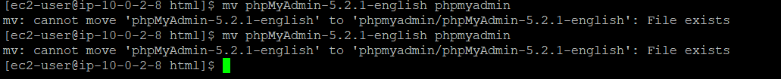mv phpMyAdmin-5.2.1-english phpmyadmin

***Figure 42: Change successfully***

***Step 1.4.10:*** Open WinSCP, navigate to phpmyadmin directory (var/www/html/phpmyadmin), and change the name of config.sample.inc.php file to config.inc.php

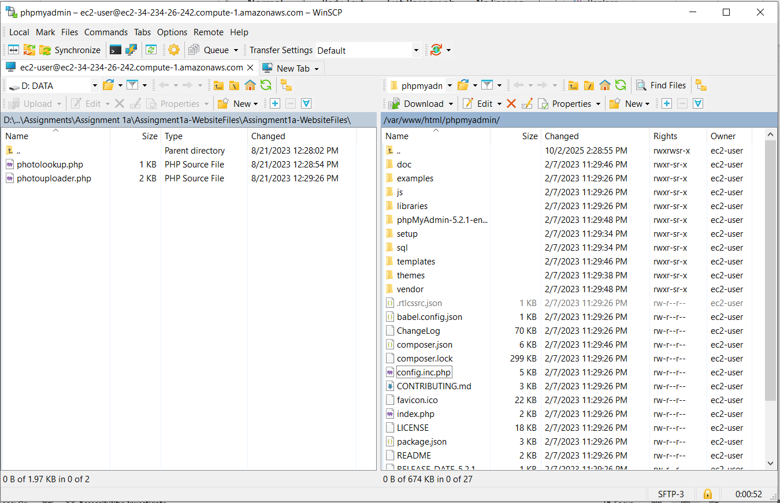***Figure 43: NamedChange successfully***

***Step 1.4.11:*** Open config.inc.php file and look for this line:

$cfg['Servers'][$i]['host'] = 'localhost';

Replace ‘localhost’ with the endpoint of your RDS instance.

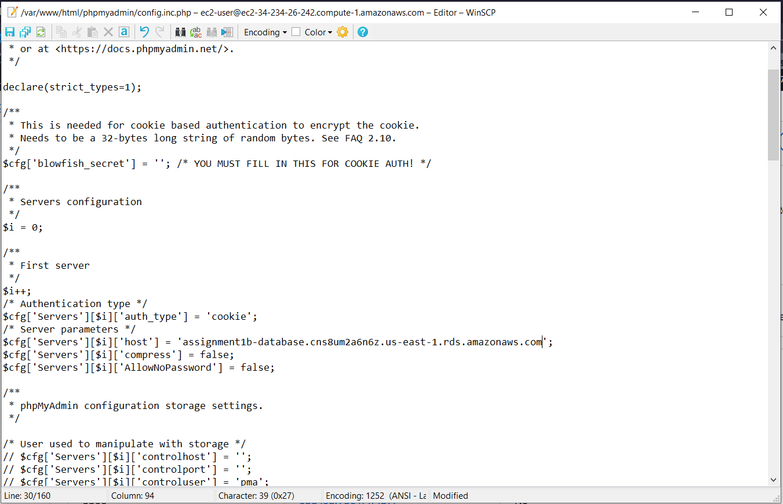  
***Figure 44: Changed successfully***

***Step 1.4.12:*** Paste the link below to a new tab:

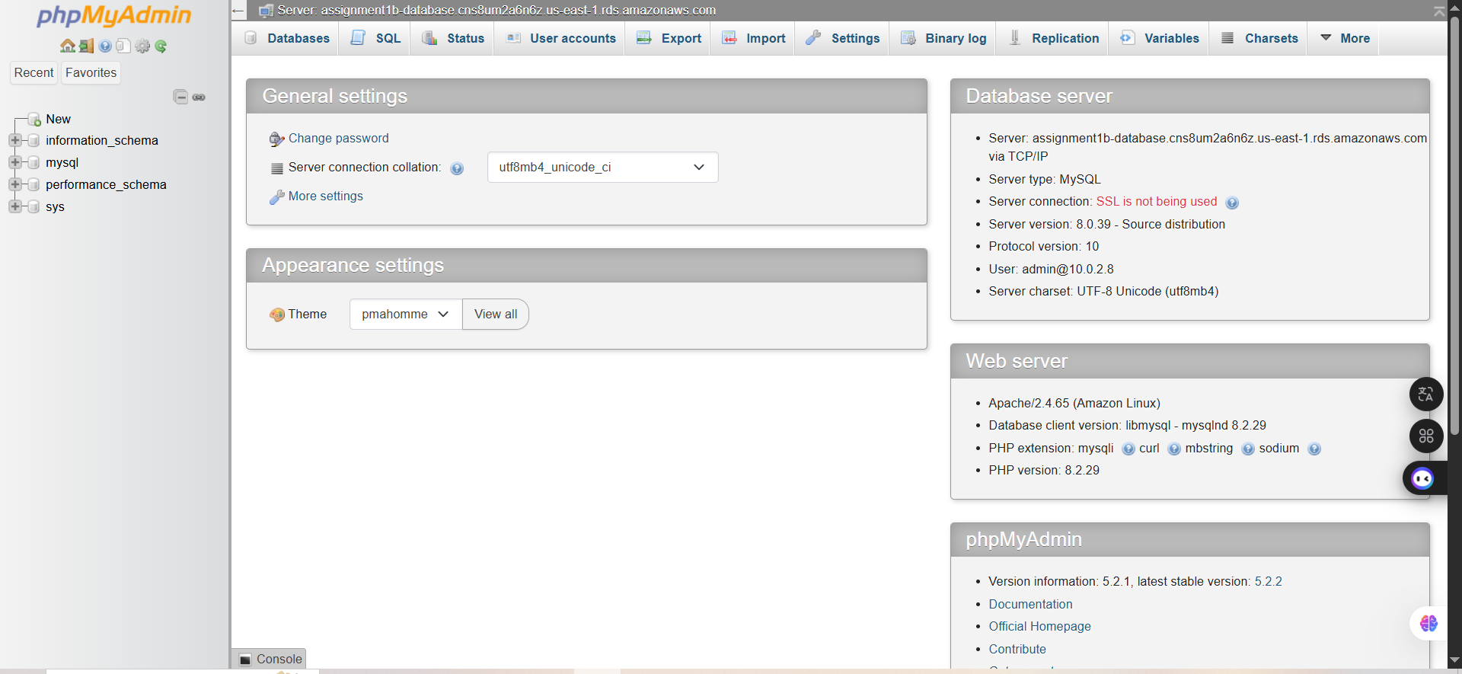 <http://ec2-34-234-26-242.compute-1.amazonaws.com/phpmyadmin/>

***Figure 45: Access successfully***

***Step 1.4.13:*** Create new table with following requirements:

+ Photo title (varchar(255) type)

+ Description (varchar(255) type)

+ Creation date (date type)

+ Keywords (varchar(255) type)

+ Reference to the photo object in S3 (varchar(255) type)

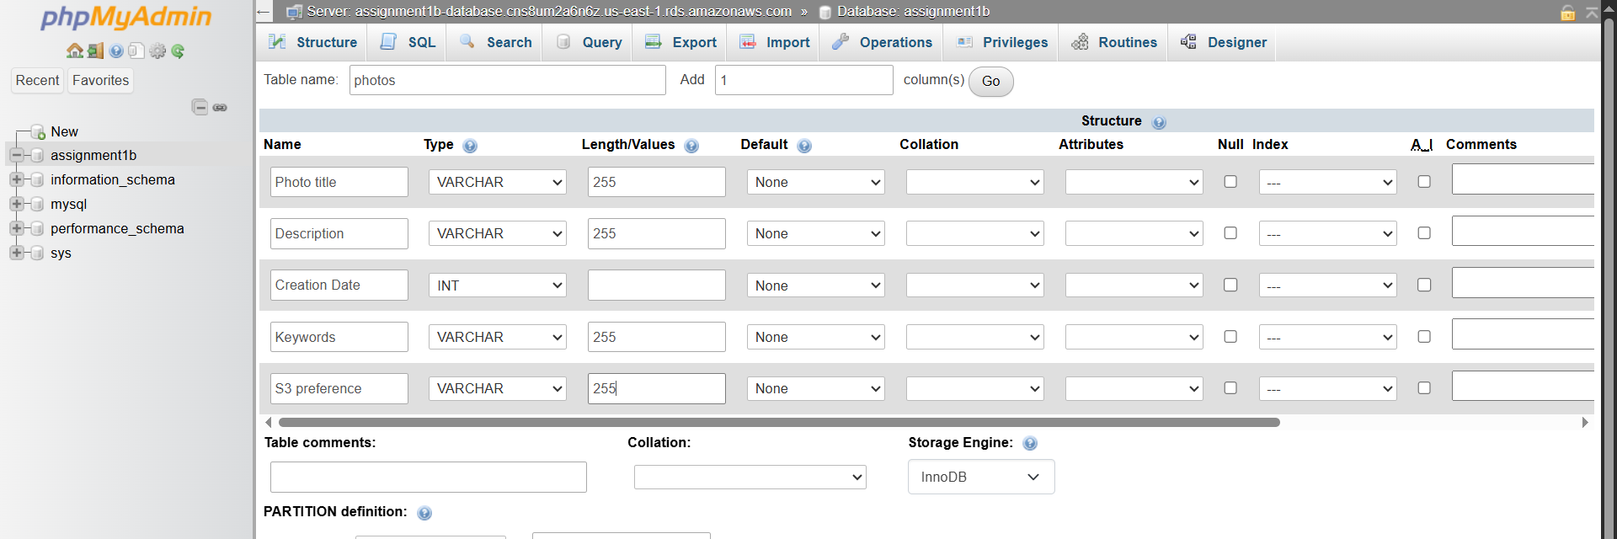

***Figure 46: Table configuration***

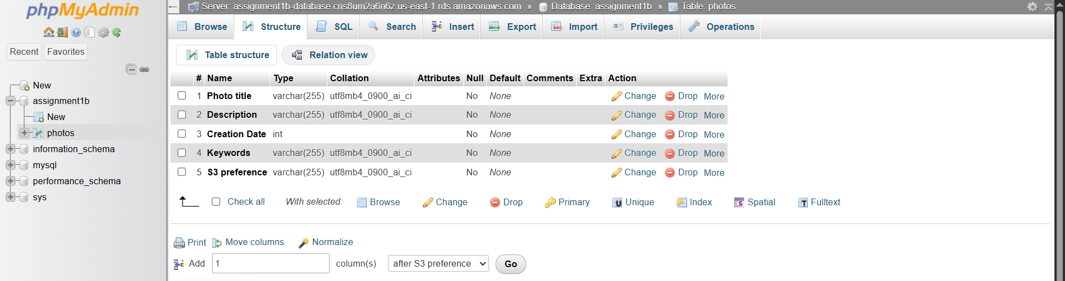

***Figure 47: Table created successfully***

***Step 1.5: Network ACL***

***Step 1.5.1:*** Search and select the **VPC**, choose **Network ACLs** and select button **Create network ACL**

***+* Name:**PublicSubnet2NACL

+ **VPC:** THieu-VPC

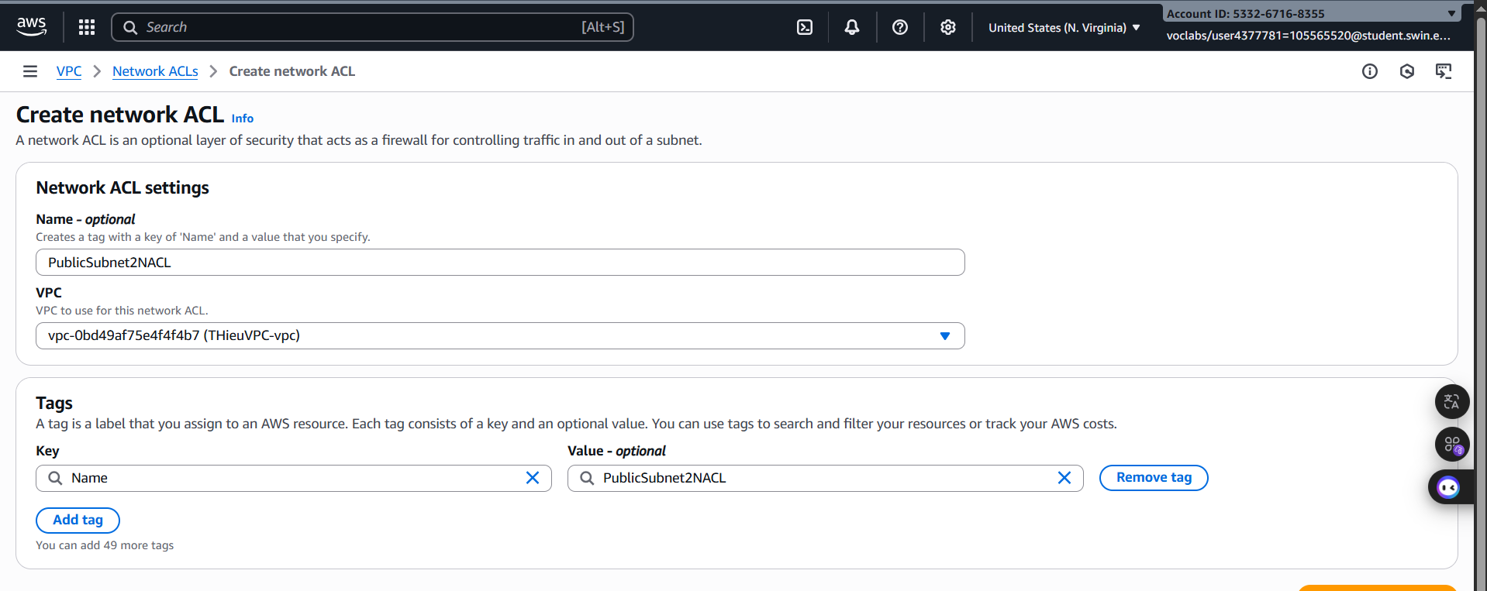 ***Figure 48: Basic configuration***

***Step 1.5.2:*** After created successfully, click **Edit Inbound rules** with following configurations:

+ must ALLOW SSH(22) 1traffic from anywhere so that you can access the WebServer instance.

+ must ALLOW ICMP traffic only from the subnet that contains the Test instance.

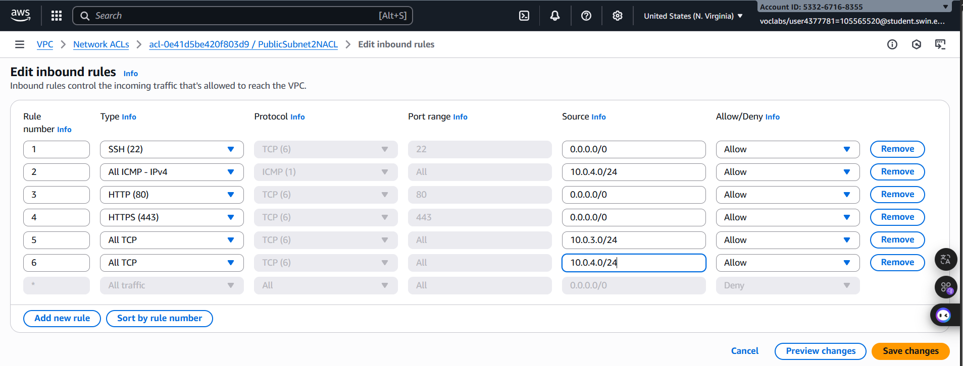 + must ALLOW other necessary traffic so that the Photo Album website is fully functional for users from anywhere.

***Figure 49: Inbound configuration***

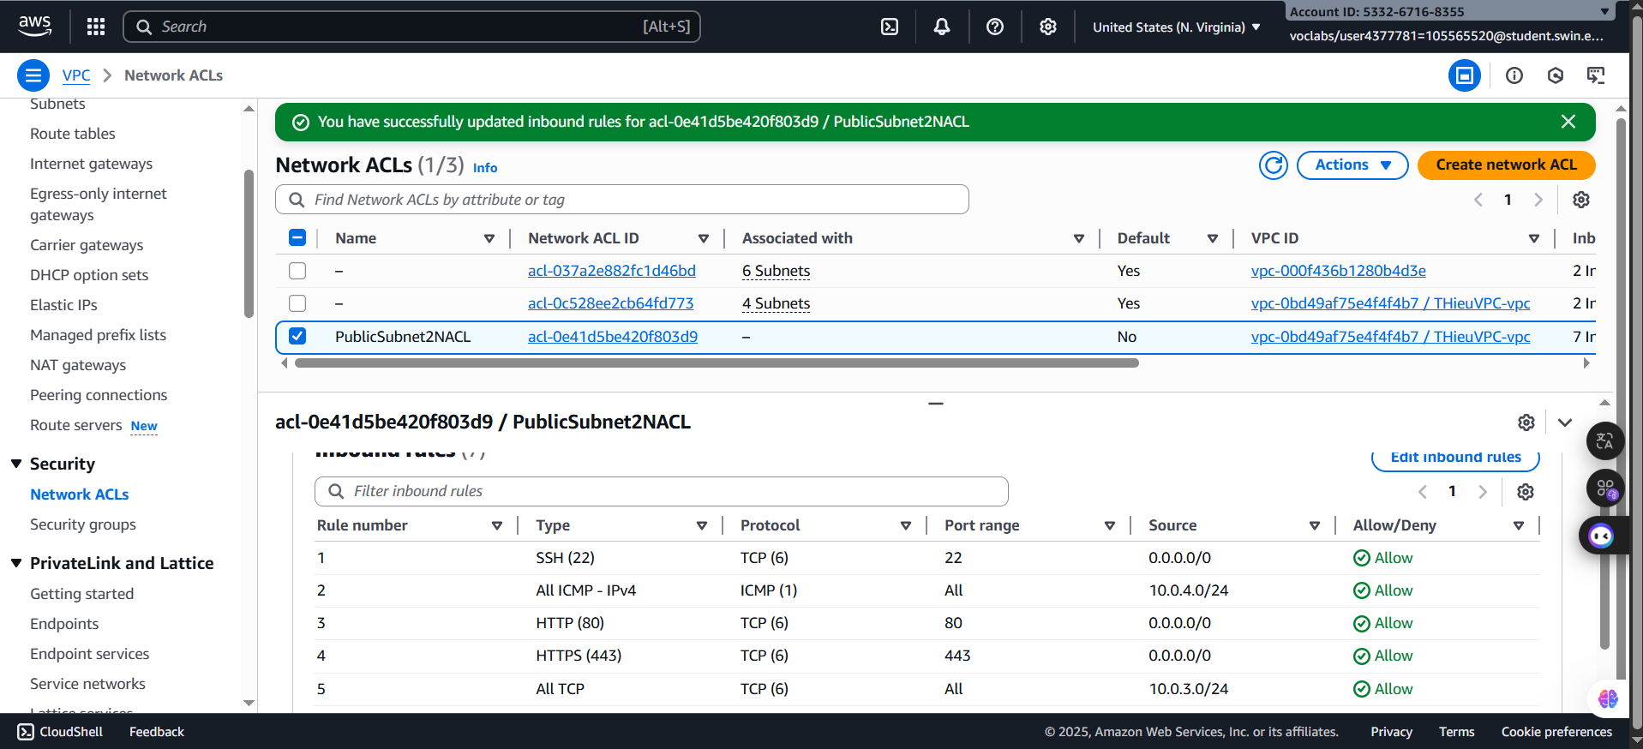 ***Figure 50: Inbound rule set successfully***

***Step 1.5.3:*** Then, edit the outbound rules

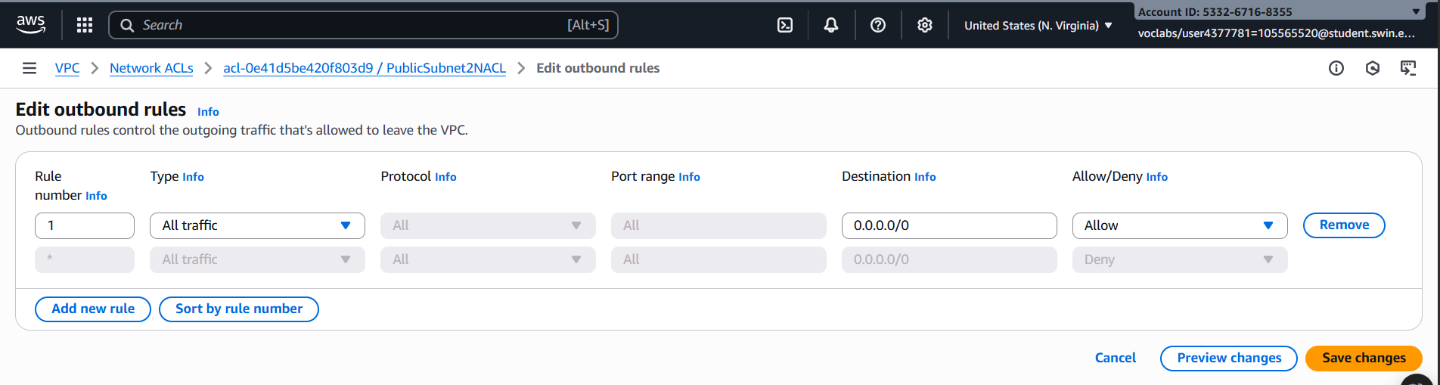

***Figure 51: Outbound rule configuration***

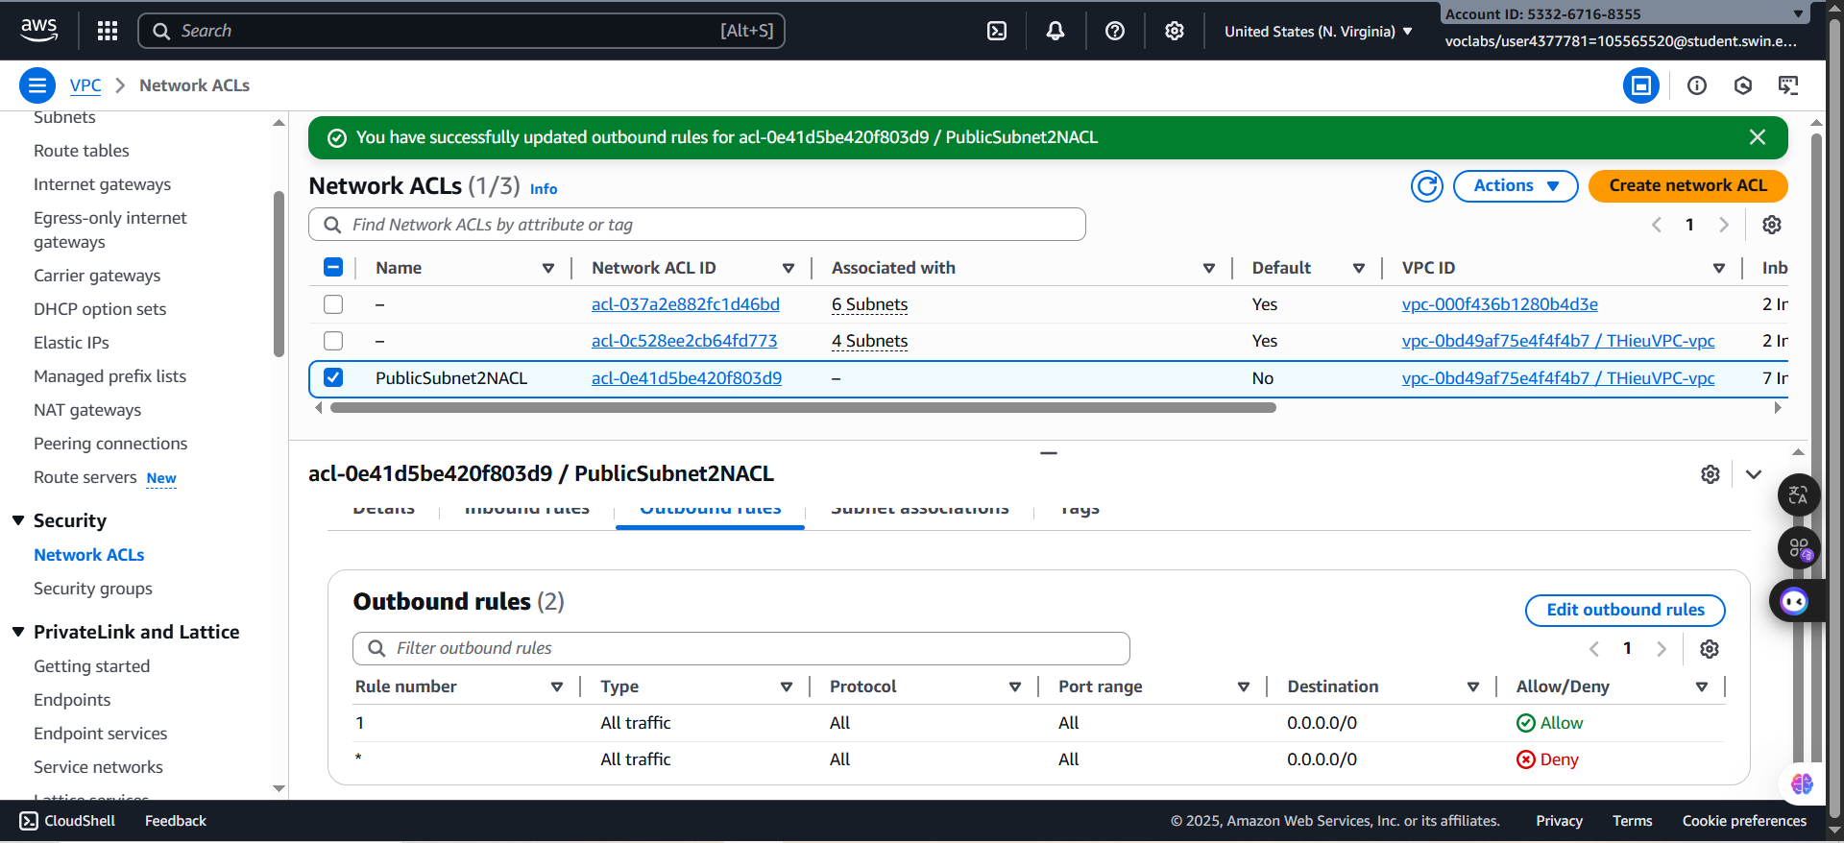

***Figure 52: Outbound rule set successfully***

***Step 1.5.4:*** Next, select the **Subnet associations**

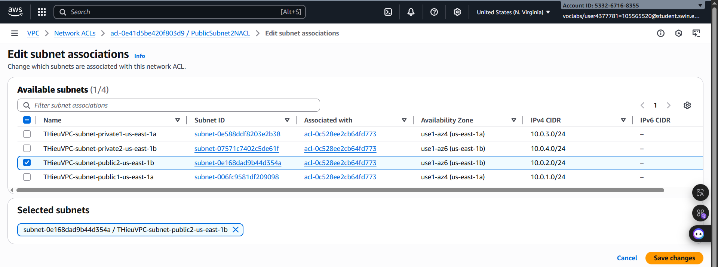

***Figure 53: Subnet associations configuration***

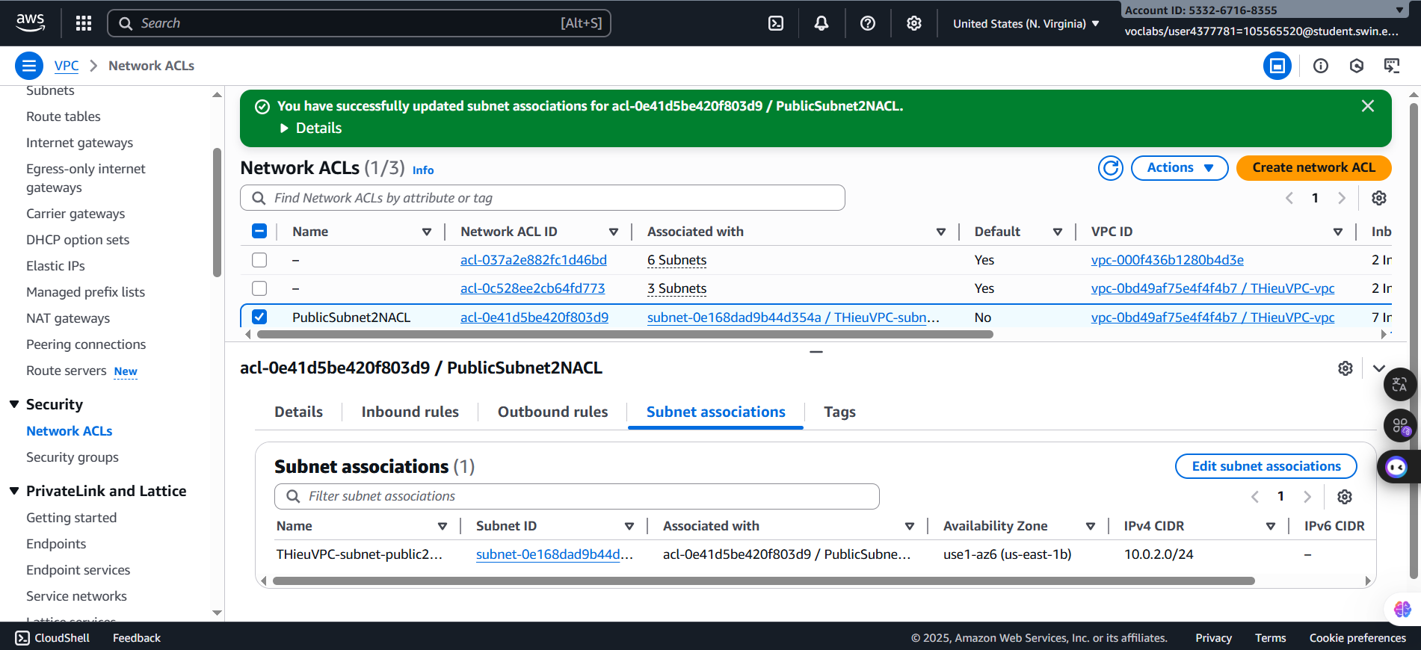

***Figure 54: Subnet associations successfully***

**Part II. Infrastructure deployment**

Functional requirements of Photo Album website Your Photo Album website must have the following functional requirements**.**

***Step 2.1: Photo storage***

***Step 2.1.1:*** Search and select the **S3** and choose **Create bucket** button

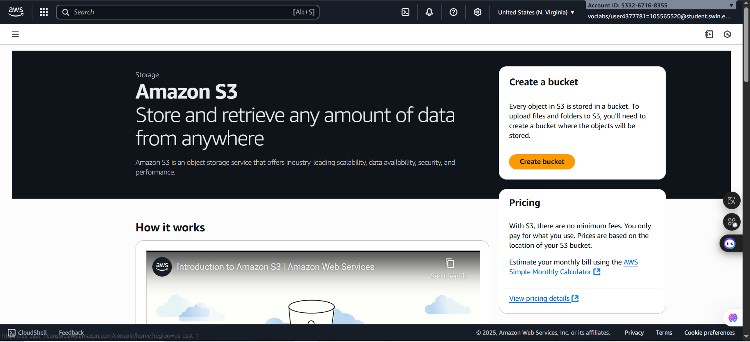

***Figure 55: S3 Homepage***

***Step 2.1.2:*** Configure with following settings:

+ **Bucket Name:** ghieu-assign1b-bucket

+ **Object Ownership:** ACLs disabled (recommended)

+ **Block Public Access settings for this bucket:** Tick the box *Turning off block all public access might result in this bucket and the objects within becoming public*

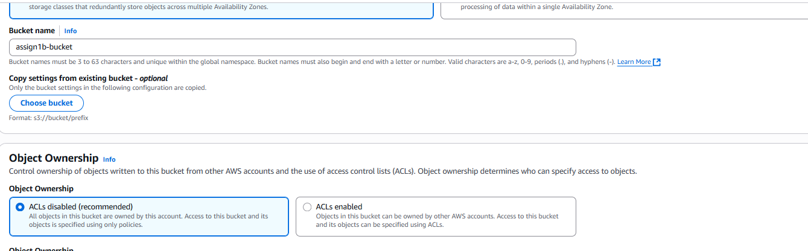

***Figure 54: General Configuration***

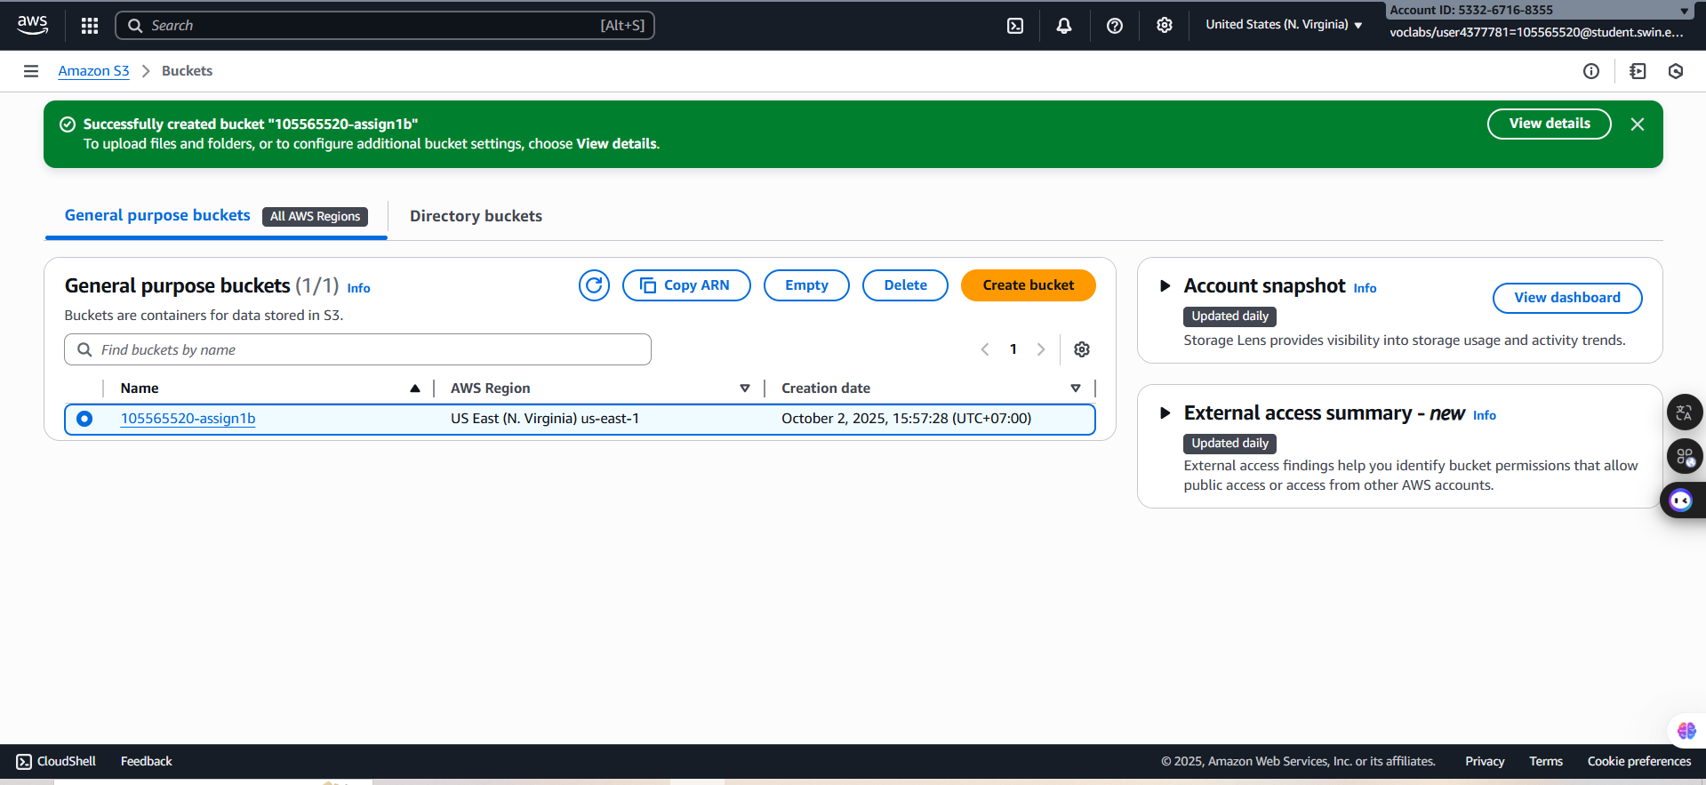

***Figure 55: Created successfully***

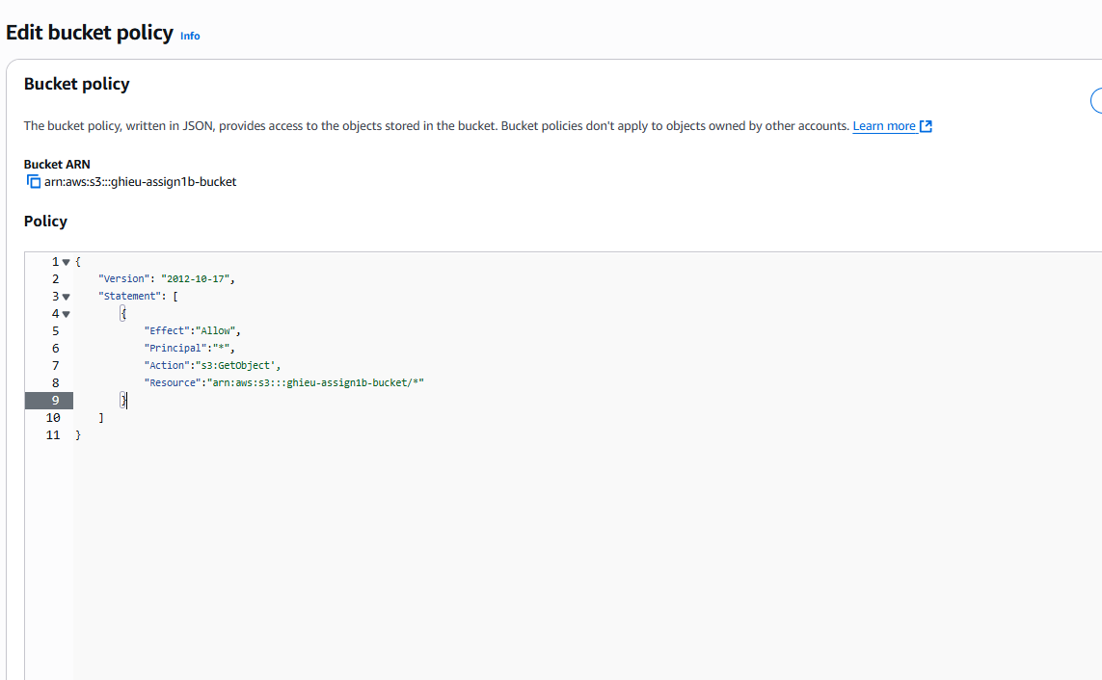 ***Step 2.1.3:*** After creating successfully, select itself, and choose tab **Permissions.** Next, select the **Edit** button in **Bucket Policy** part.

***Figure 56: Bucket policy configuration***

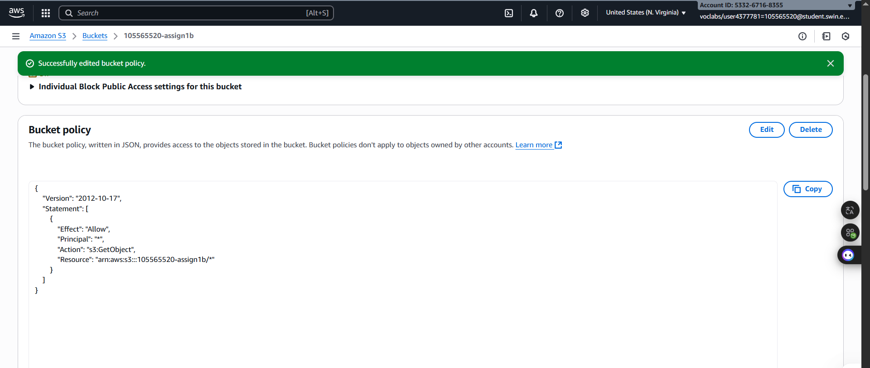

***Figure 57: Saved changed successfully***

***Step 2.1.4:*** Then, upload two example of images to S3

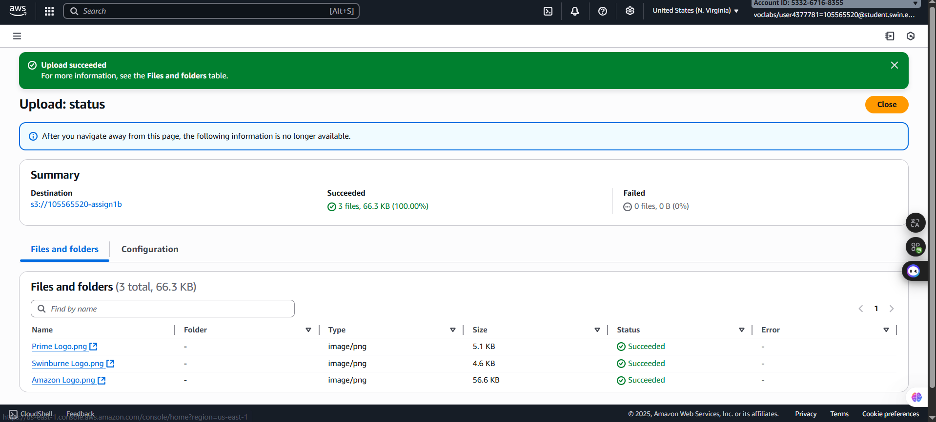

***Figure 58: Uploaded successfully***

***Step 2.1.5:*** Open the phpAdmin and add value

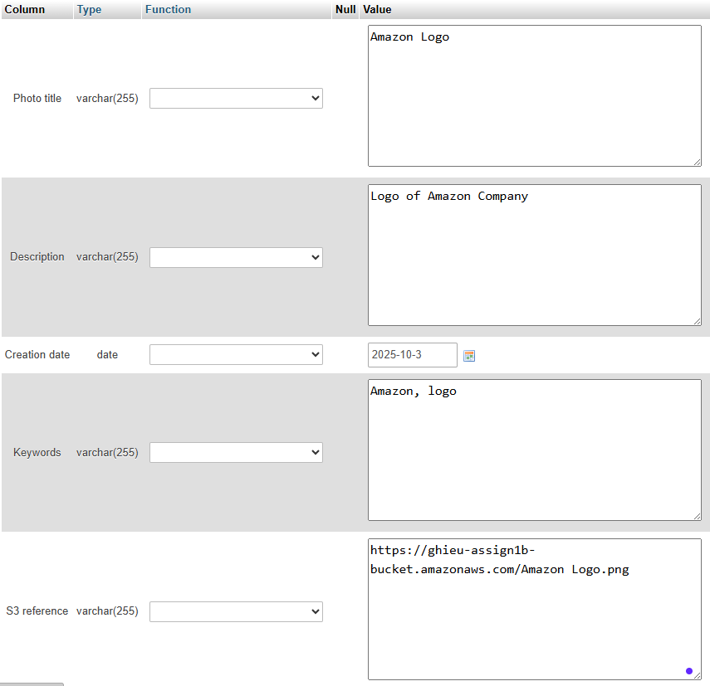

***Figure 59: Amazon Logo configuration***

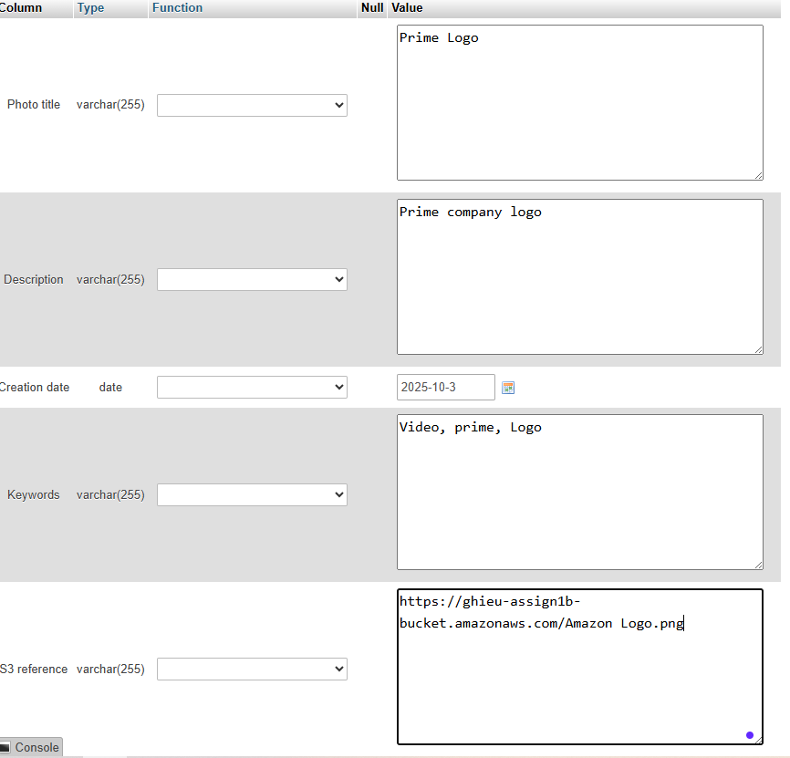

***Figure 60: Prime Logo configuration***

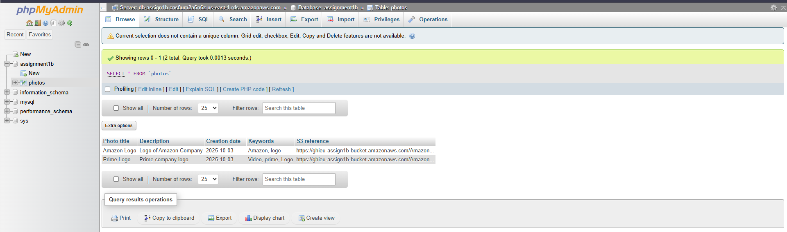

***Figure 61: Configuration created successfully***

***Step 2.1.6:*** Open the WinSCP to configure the datafile **constants.php**

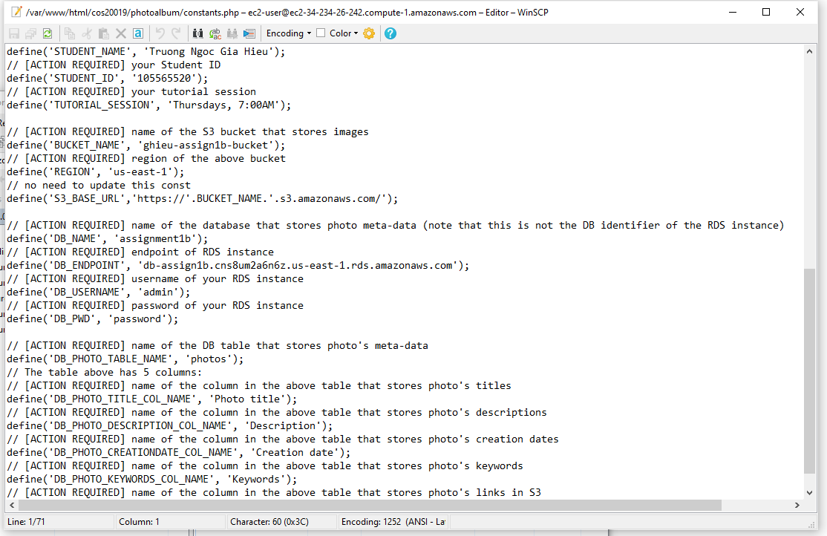***Figure 62: File configuration***

***Step 2.1.7:*** By pasting the link below which allow the result displays

[***/http://34.234.26.242/cos20019/photoalbum/album.php***](http://http://34.234.26.242/cos20019/photoalbum/album.php)

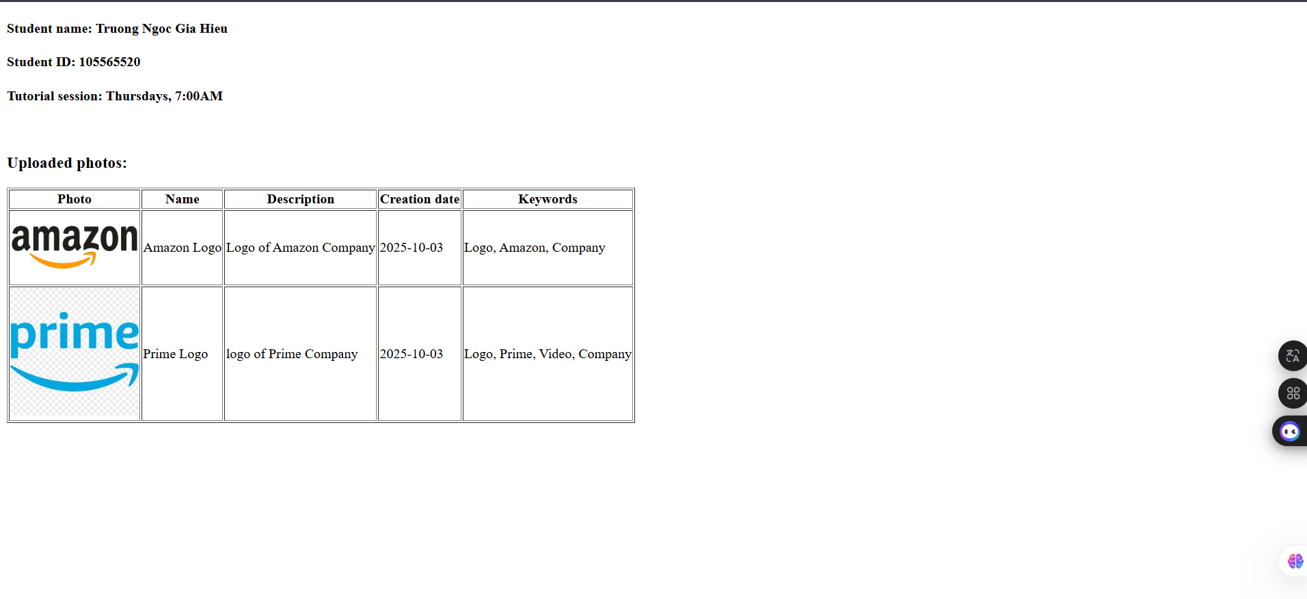

***Figure 62: Completed task***

**Part III. Conclusion**

- In completing this assignment, I successfully designed and deployed a secure cloud-based photo album application on AWS. The process involved creating a custom VPC with both public and private subnets, configuring routing tables, and applying appropriate security groups and network ACLs to enforce the principle of least privilege. I deployed an Apache web server on an EC2 instance, integrated an RDS MySQL database for photo meta-data storage, and configured an S3 bucket for hosting the photo objects with proper access policies.

- Through this implementation, I gained hands-on experience in setting up a scalable and secure cloud infrastructure, troubleshooting configuration issues, and ensuring the seamless connection between different AWS services. The project not only strengthened my technical understanding of cloud architecture but also highlighted the importance of security, resource management, and documentation in a real-world deployment.

- Overall, this assignment provided me with valuable insights into cloud computing practices and gave me confidence in applying AWS services to build reliable web applications.